1. National Aggregate
2. Country
3. Standard Region
4. ITU Region best �it
5. ITU Region n/o 1
6. ITU Region n/o 2
7. ITU Region n/o 3
8. EEC Level 2 Region
9. Regional Health Authority
10. Police Authority Area
11. County
12. European AsseMbly Area
13. GPO Postcode Area
14. Local Education Authority
15. CURDS Functional City
16. CIPFA Library Area
17. District Health Authority Area
18. CURDS Local Labour Market Area
19. Travel-to-work Area
20. District
21. ParliaMentary Constituency
22. AMalg. EMployMent O��ice Area

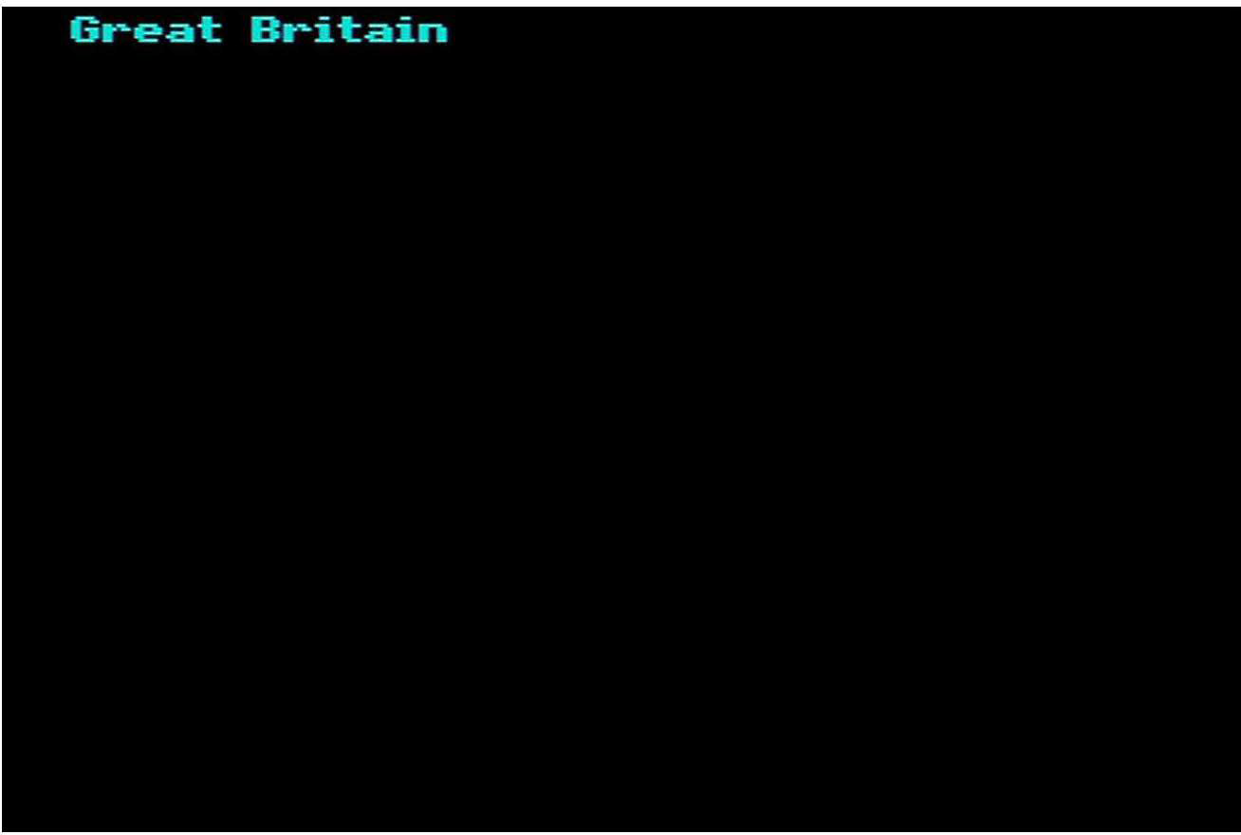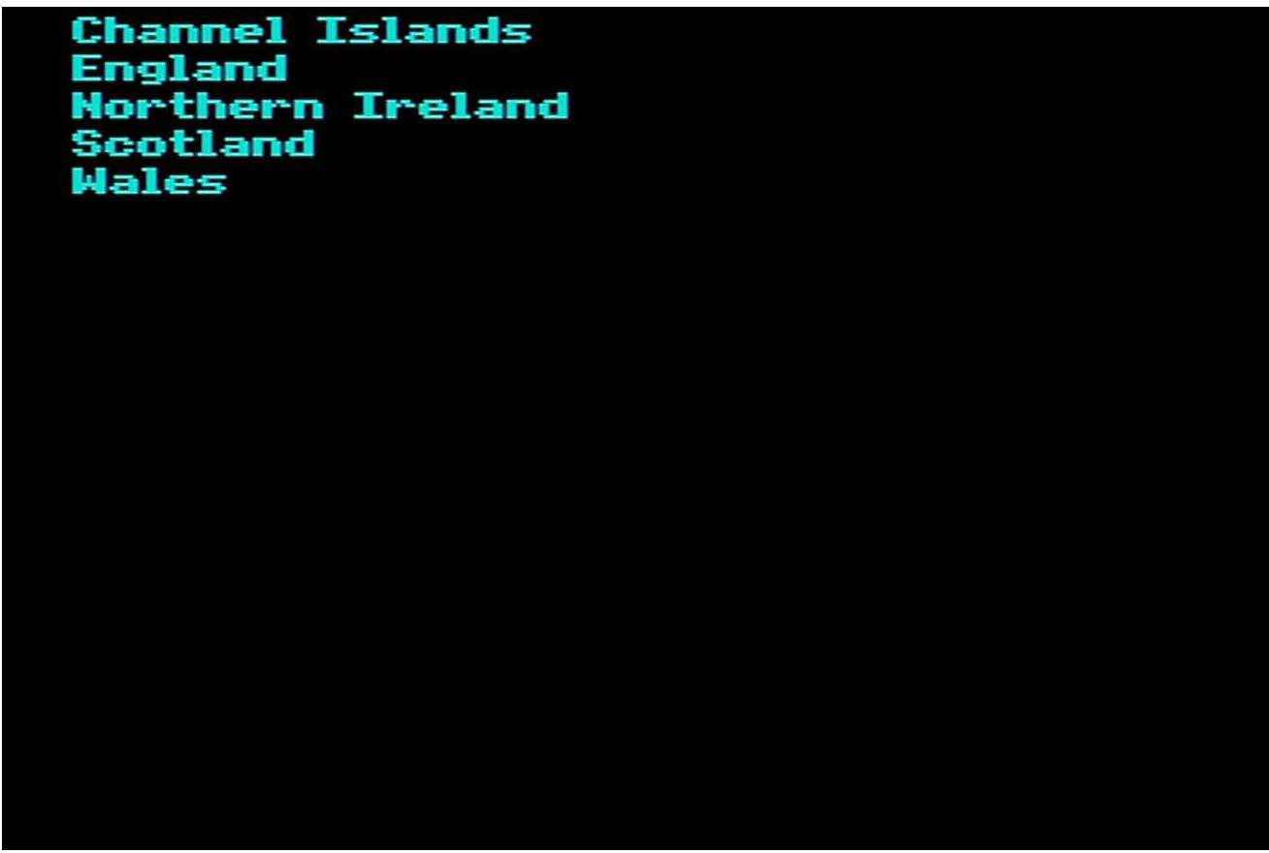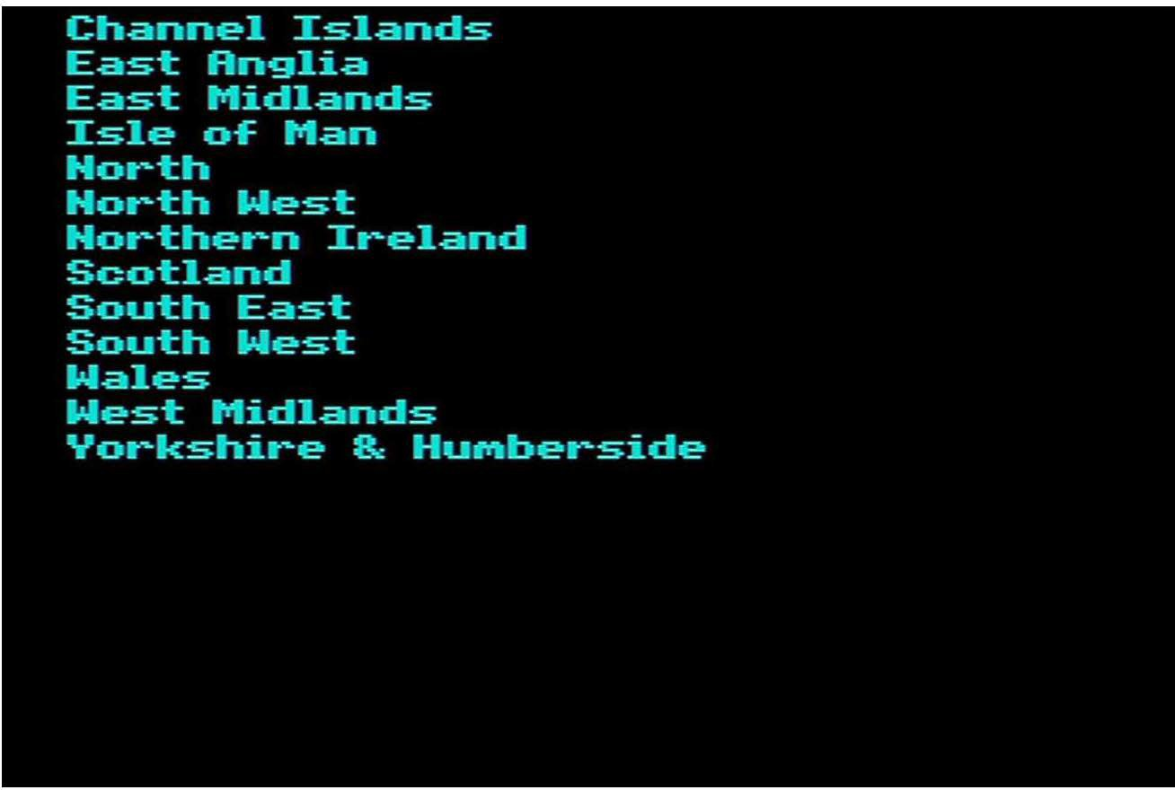

Anglia Border Central Channel GraMpian Granada

Harlech (CyMru)

Harlech <West oE England) Scottish TU

South West TU ThaMes./LWT TUS

Tyne Tees Ulster Yorkshire

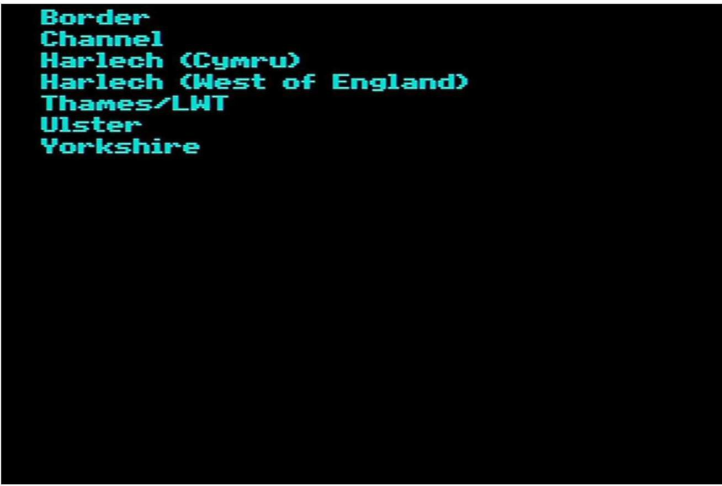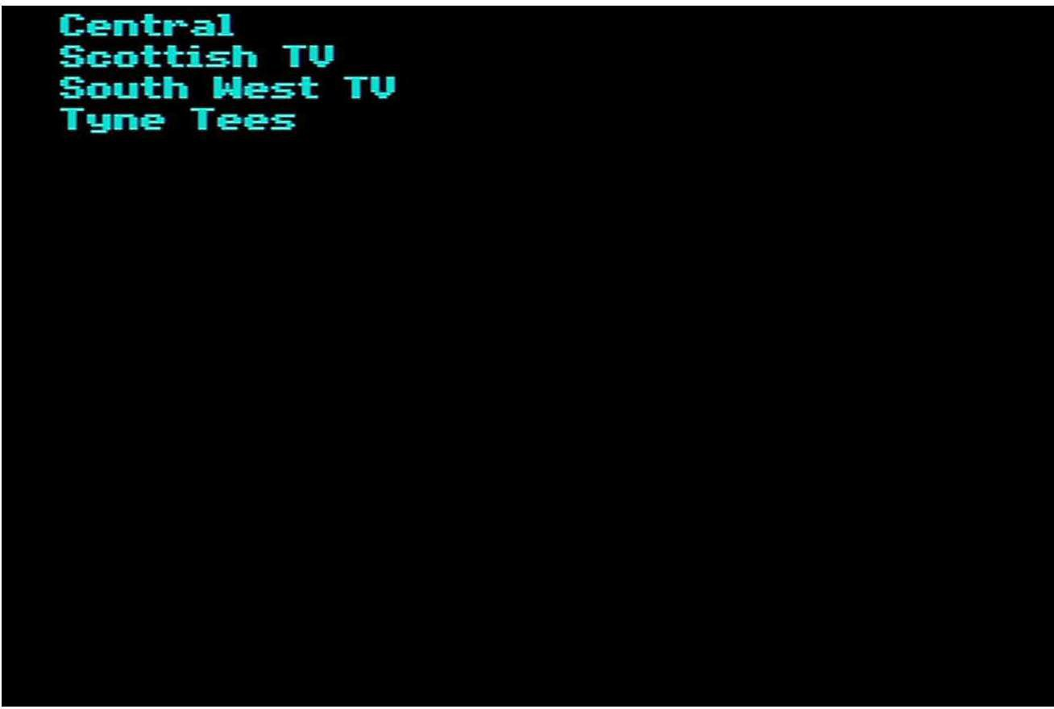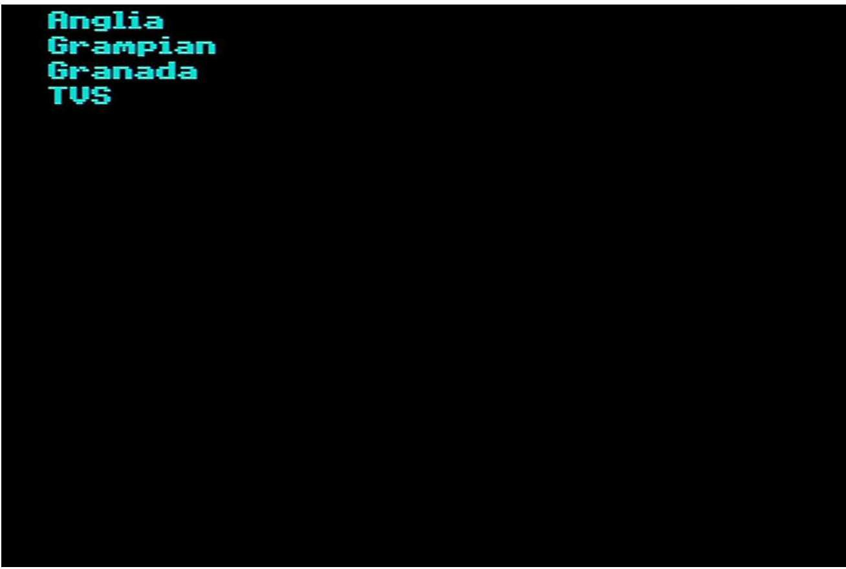

East Anglia East Midlands Greater London

Greater Manchester Metropolitan County Merseyside Metropolitan County Northern Ireland

ReMainder of Horth West ReMainder of Northern Region ReMainder of South East ReMainder of West Midlands

ReMainder of Yorkshire and HuMberside Scotland

South West

South Yorkshire Metropolitan County Tyne and Wear Metropolitan County Wales

West Midlands Metropolitan County West Yorkshire Metropolitan County

Argyll 8.: Clyde

Ayrshire 8.: Arran Borders

DuM-fries and Galloway East Anglian

Fi-fe

Forth Ualley GraMpian Greater Glasgow Guernsey Highland

Islands Isle o-f Man Jersey Lanarkshire Lothian Mersey

Horth East ThaMes Horth West ThaMes Horth Western Northern

Northern Ireland

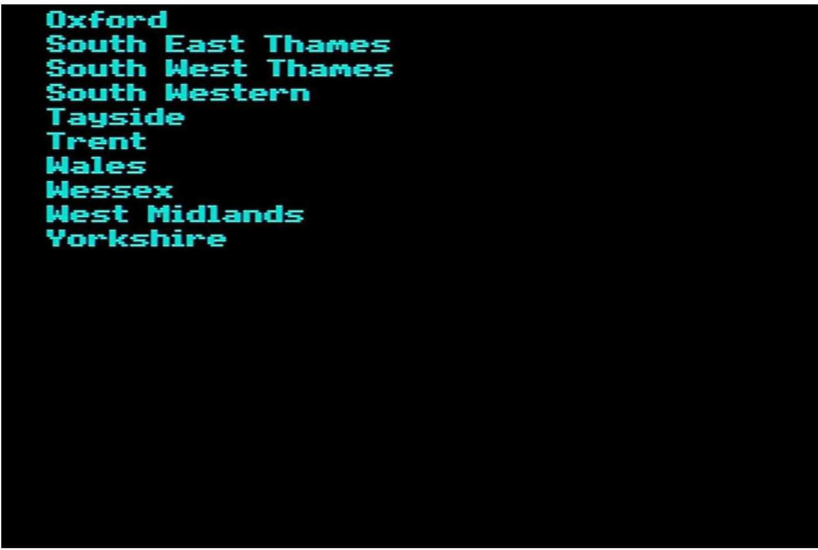

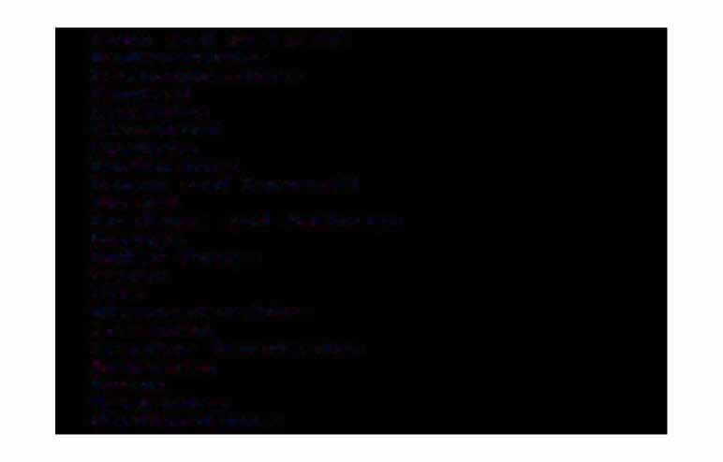Avon and SoMerset Bedfordshire CaMbridgeshire Central

Cheshire Cleveland CuMbria Derbyshire

Devon and Cornwall Dorset

DuMfries and Galloway DurhaM

Dyfed-Powys Essex

Fife Gloucestershire GraMpian

Greater Manchester Guernsey

Gwent HaMpshire Hertfordshire

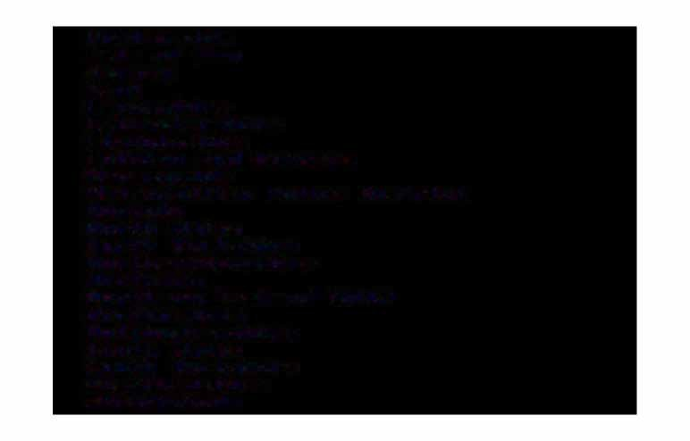HuMberside Isle of Man Jersey

Kent Lancashire Leicestershire Lincolnshire

Lothian and Borders Merseyside

Metropolitan Police District Norfolk

Horth Wales Horth Yorkshire HorthaMptonshire Northern

Northern Ireland <RUC> HorthuMbria HottinghaMshire

South Wales South Yorkshire Staffordshire Strathclyde

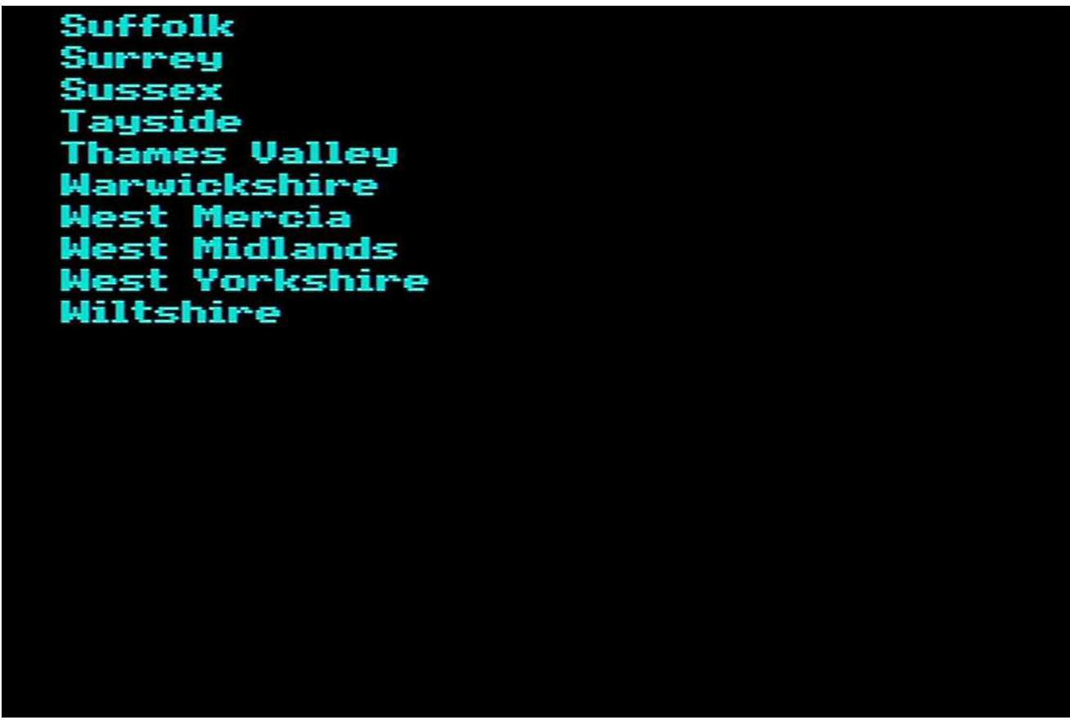

Avon

Bed-fordshire Bel-fast <CB) Berkshire Borders BuckinghaMshire CaMbridgeshire Central

Cheshire Cleveland Clwyd

Co. AntriM Co. ArMagh Co. Down

Co. FerManagh Co. Londonderry Co. Tyrone Cornwall CuMbria Derbyshire Devon

Dorset

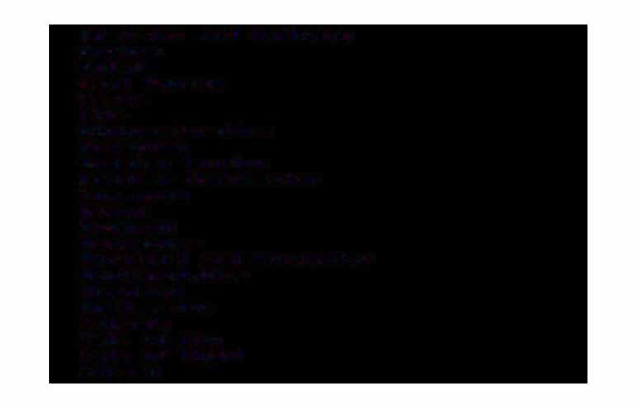DuM-fries and Galloway DurhaM

Dy-fed

East Sussex Essex

Fi-fe Gloucestershire GraMpian Greater London

Greater Manchester Guernsey

Gwent Gwynedd HaMpshire

Here-ford and Worcester Hert-fordshire

Highland HuMberside Islands Isle o-f Man

Isle o-f Wight Jersey

Kent Lancashire Leicestershire Lincolnshire Lothian Merseyside

Mid GlaMorgan

**Norfolk**

**Horth** Yorkshire HorthaMptonshire HorthuMberland HottinghaMshire Oxfordshire Powys

Shropshire SoMerset

South GlaMorgan South Yorkshire Staffordshire Strathclyde Suffolk

Surrey

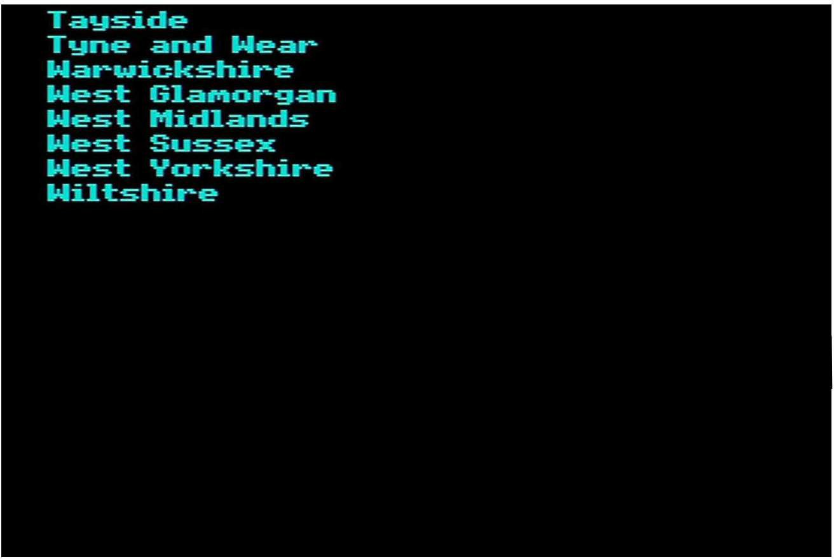

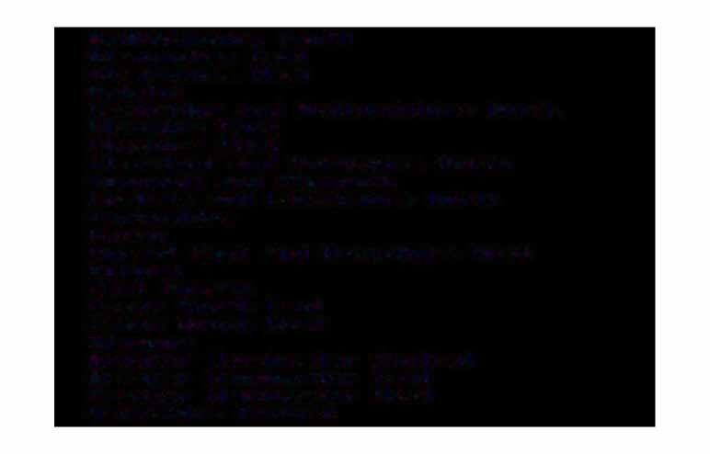Bed�ordshire South BirMinghaM East BirMinghaM West Bristol

CaMbridge and Bed�ordshire Horth Cheshire East

Cheshire West

Cleveland and Yorkshire Horth Cornwall and PlyMouth

CuMbria and Lancashire Horth Derbyshit�e

Devon

Dorset East and HaMpshire West DurhaM

East Sussex Essex Horth East Essex South West Glasgow

Greater Manchester Central Greater Manchester East Greater Manchester West HaMpshire Central

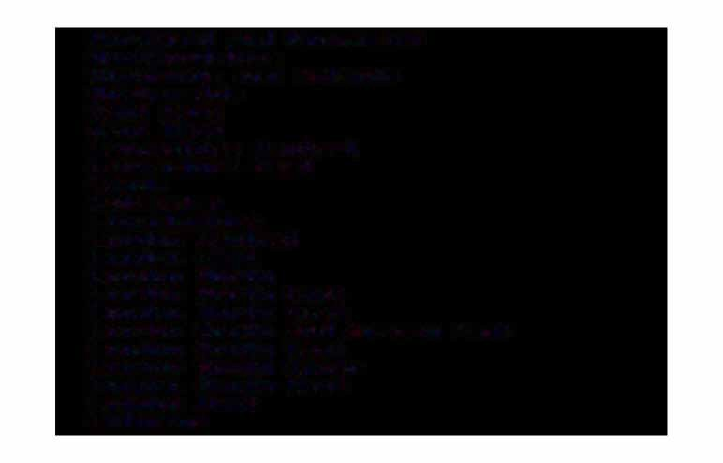Heref'ord and Worcester Hertf'ordshire

Highlands and Islands HuMberside

Kent East Kent West

Lancashire Central Lancashire East Leeds

Leicester Lincolnshire London Central London East London Horth London Horth East London Horth west

London South and Surrey East London South East

London South Inner London South West London West Lothians

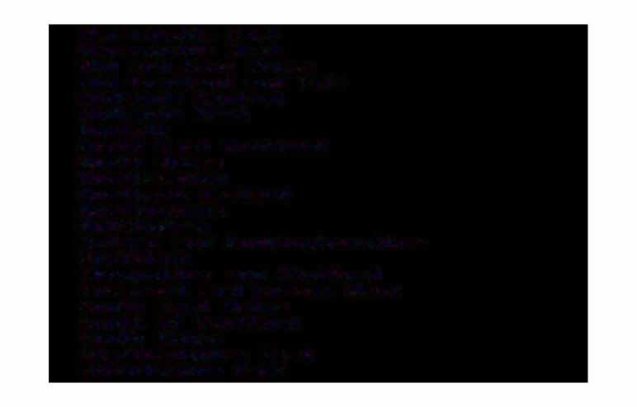Merseyside East Merseyside West Mid and West Wales

Mid Scotland and FiEe Midlands Central Midlands West

HorEolk

Horth East Scotland Horth Wales HorthaMpton Northern Ireland HorthuMbria HottinghaM

OxEord and BuckinghaMshire SheEEield

Shropshire and StaEEord SoMerset and Dorset West South East Wales

South oE Scotland South Wales StaEEordshire East Strathclyde East

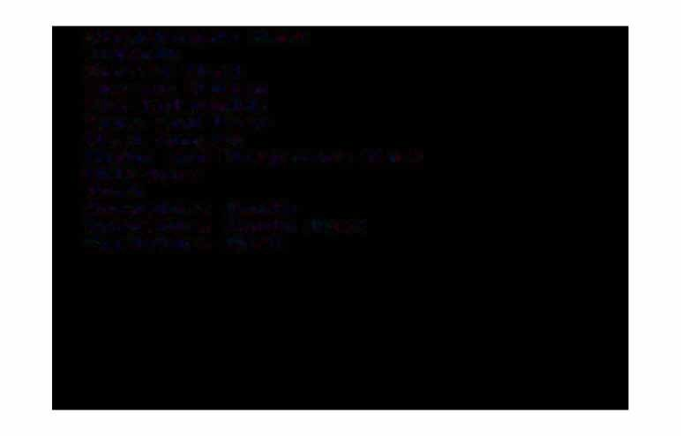Strathclyde West Su-f-folk

Surrey West ThaMes Valley The Cotswolds Tyne and Wear West Sussex

Wight and Hatl'llpshire East Wiltshire

York

Yorkshire South Yorkshire South West Yorkshire West

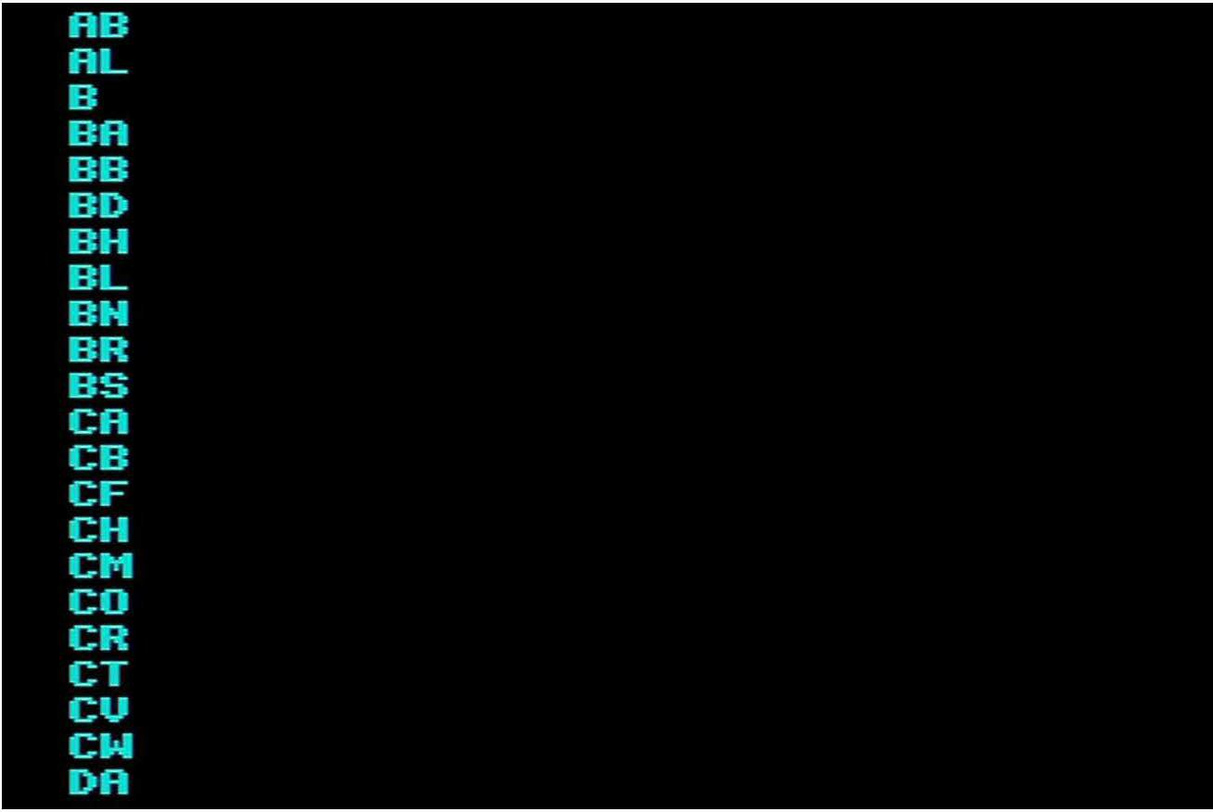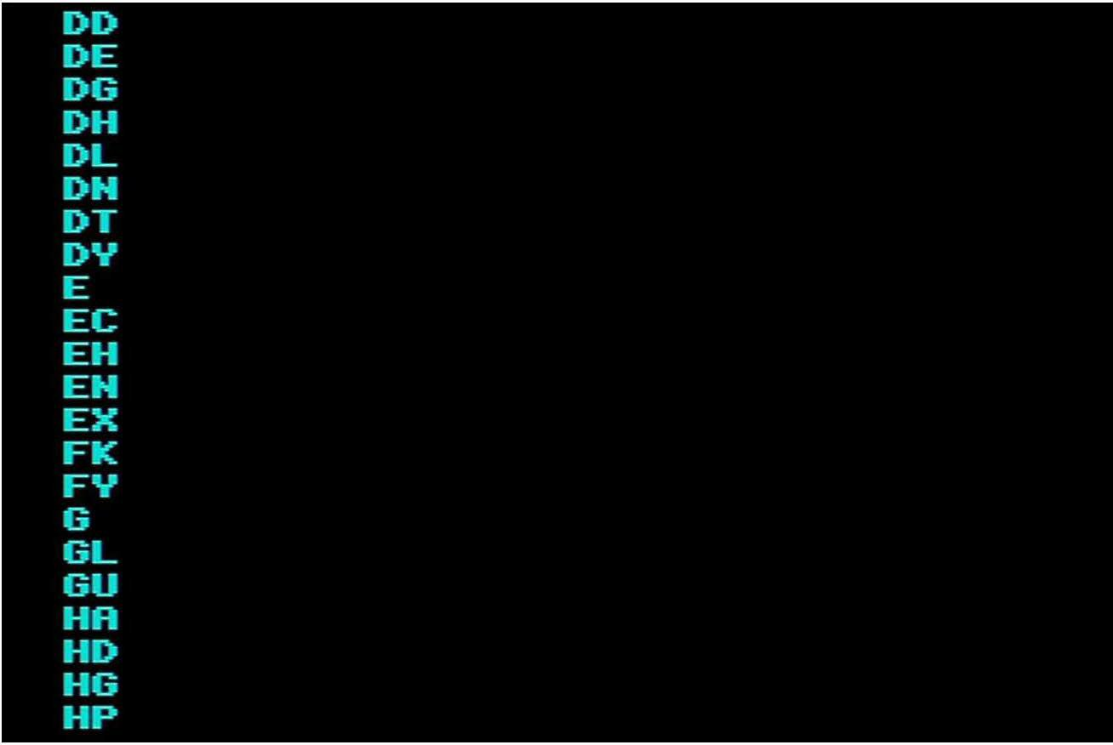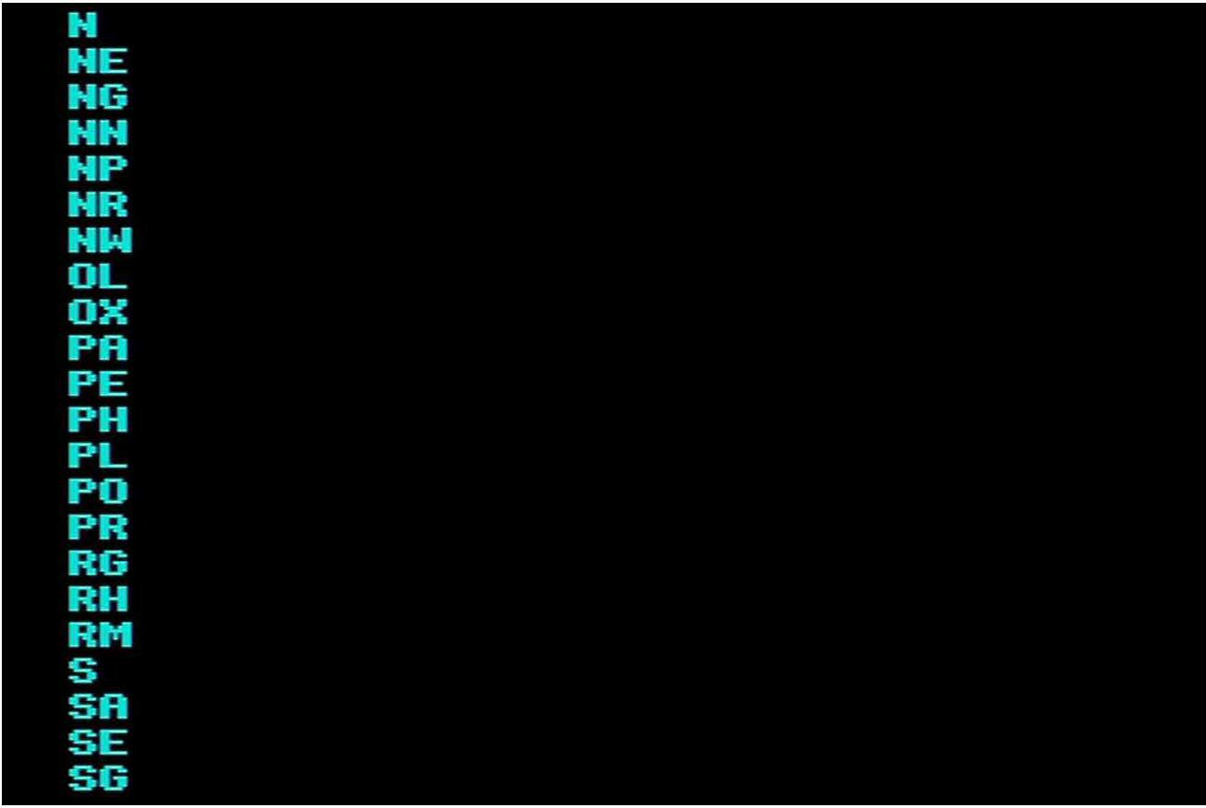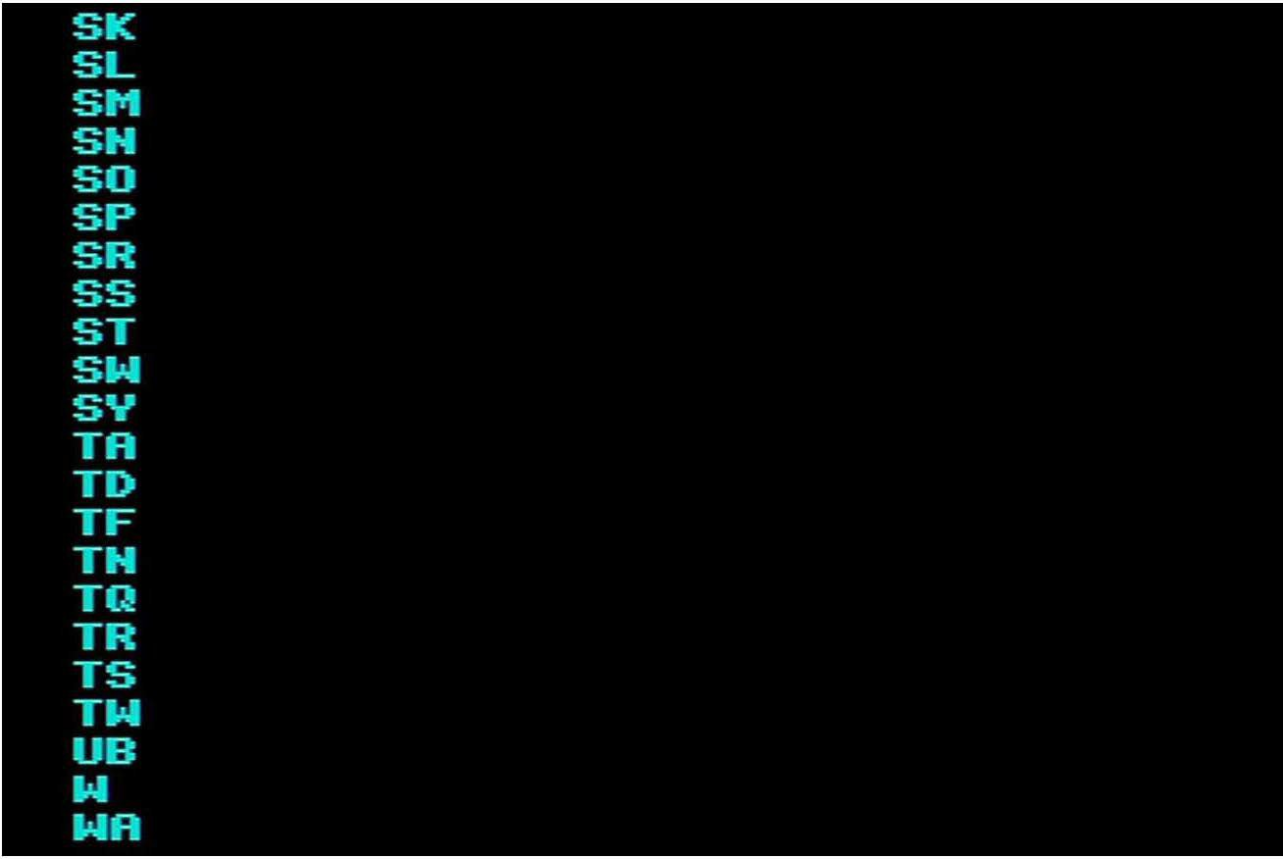

Avon

Barking and DagenhaM Barnet

Barnsley BedEordshire BelEast Berkshire Bexley BirMinghaM Bolton Borders BradEord Brent BroMley

BuckinghaMshire Bury

Calderdale CaMbridgeshire Central Cheshire Cleveland Clwyd

Cornwall Coventry Croydon CuMbria Derbyshire Devon Doncaster Dorset Dudley

DuM-fries: and Galloway DurhaM

Dy-fed Ealing

East Sussex En-field Essex

Fi-fe Gateshead

Gloucestershire Gt�aMpian Guernsey

Gwent

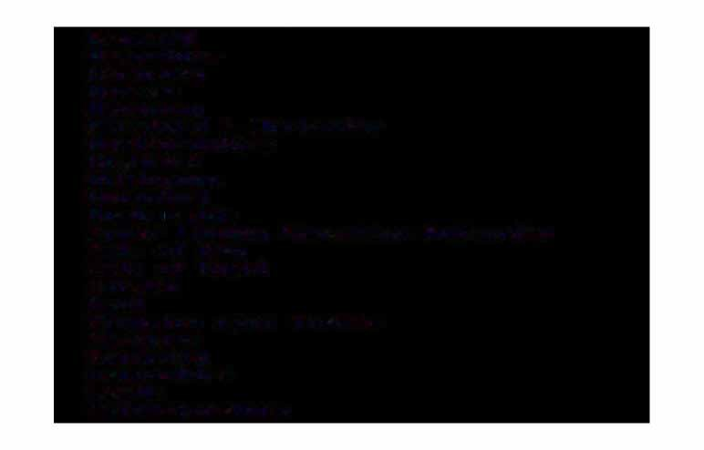Gwynedd HaMpshire Haringey Harrow Havering

Heret=ord & Worcester Hertt=ordshire Highland

Hillingdon Hounslow HuMbet�side

Inner London Education Authority Isle of= Man

Isle of= Wight

.Jersey Kent

Kingston upon ThaMes Kirklees

Knowsley Lancashire Leeds Leicestershire

Lincolnshire Liverpool Lothian Manchester Merton

Mid GlaMorgan Newcastle upon Tyne HewhaM

Hor-folk

Horth Eastern Horth Tyneside Horth Yorkshire HorthaMptonshire HorthuMberland HottinghaM:shire OldhaM

Orkney Isles Ox-fordshire Powys

Redbt-idge

RichMond upon ThaMes Rochdale

RotherhaM Sal-ford Sandwell Se-fton She-f-field

Shetland Isles: Shropshire Solihull SoMers:et South Eastern

South GlaMorgan South Tyneside Southern

St. Helens: Sta-f-fordshire Stockport Strathclyde Su-f-folk Sunderland Surrey

Sutton TaMes:ide

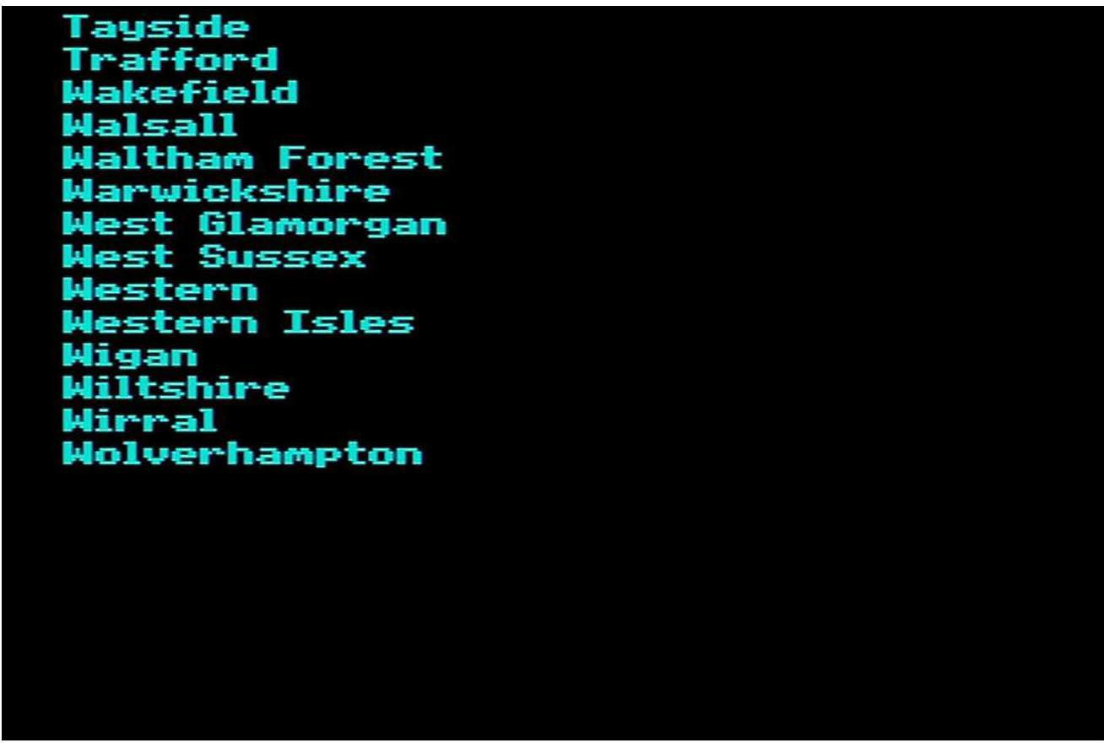

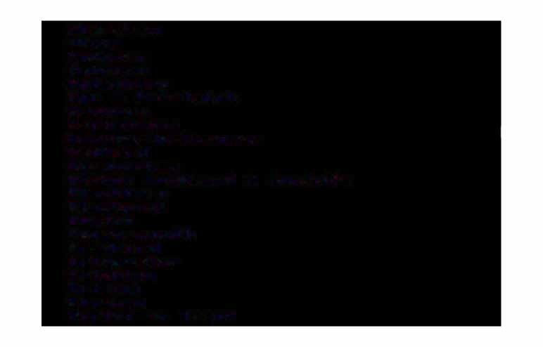Aberdeen Alloa Andover Ashford Aylesbury

Ayr & Prestwick Banbury Barnstaple

Barrow-in-Furness Bedford BirMinghaM

Bishop Auckland & Aycliffe Blackburn

Blackpool Boston BourneMouth Bradford Bridgwater Brighton Bristol Burnley

Burton on Trent

Bury St. EdMunds CaMbridge Canterbury

Cardi-f-f Carlisle CheltenhaM Chester-field

Chichester & Bognor ChippenhaM

Clacton Coalville Colchester Corby Coventry Crewe Darlington Deal

Derby Doncaster Dover

DuM-ft-ies Dundee

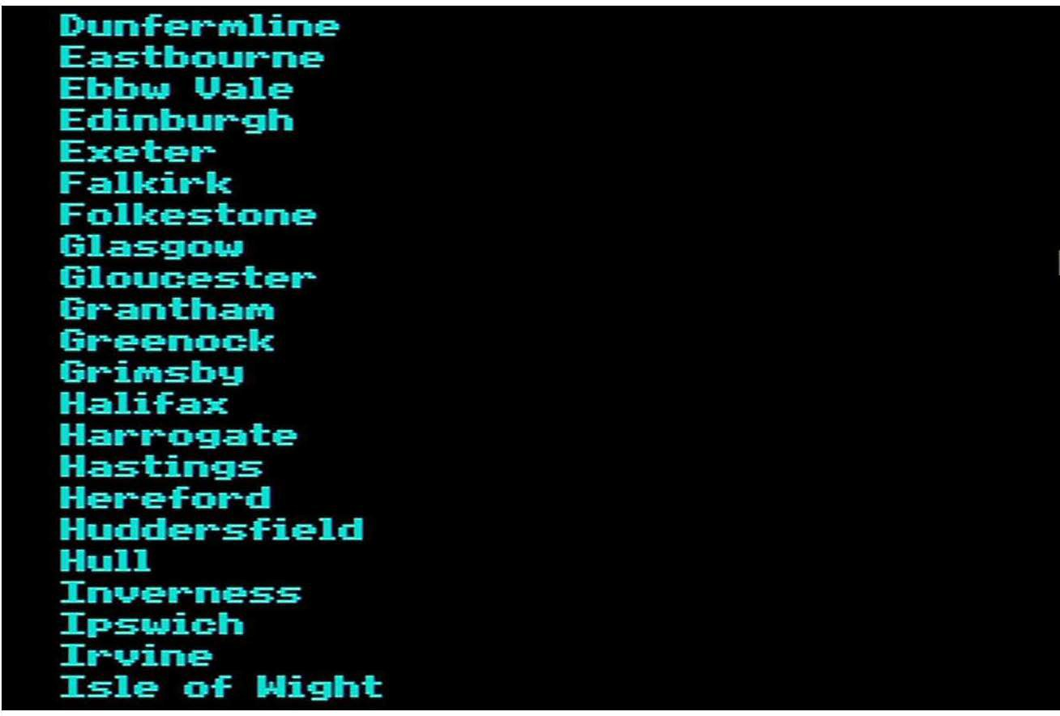

Keighley Kendal Kettering Kiddertr1inster Kiltr1.arnock Kings Lynn Kirkc.aldy Lane.aster Leeds Leicester Letchworth Lincoln Liverpool Ll.andudno Llanelli

London Dotr1inant London Subdotr1in.ants Loughborough Lowestof't

Luton Manchester

Marg.ate & R.atr1sg.ate

Merthyr Tyd-fil Middlesbt�ough Milton Keynes Helson & Colne

Newcastle-upon-Tyne Newport

Hewton Abbot Horthaf'l'llpton Horwich Hottinghaf'l'II Ox-ford

Perth Peterborough Plyti'llouth Portsti'llouth Preston

Rhyl & Prestatyn Rossendale Salisbury Scarborough Scunthorpe

She-f-field

Shrewsbury SouthaMpton St. Austell Sta-f-ford Stevenage Stirling

Stoke on Trent Stroud Sunderland Swansea Swindon Taunton

Tel-ford Torquay Trowbridge Wellingborough WeyMouth Whitehaven Winchester Worcester

Wot-kington Worksop



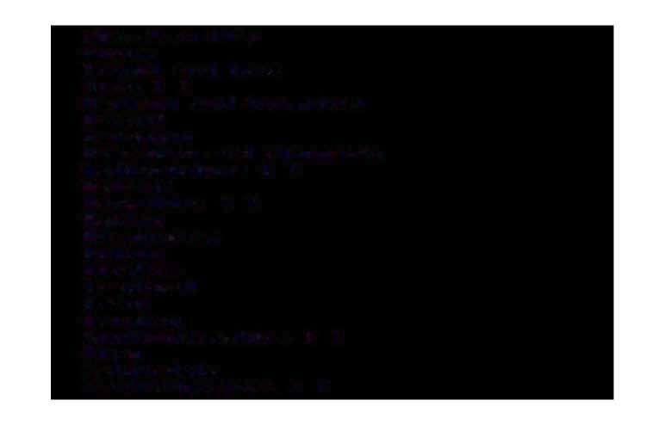Aberdeen City Angus

Argyll .and Bute Avon C C

Barking .and D.agenh.aM Barnet

Barnsley

Bearsden .and Milng.avie Bed�ordshire C C Bel�.ast

Berkshire C C Bexley BirMingh.aM Bolton Borders Br.ad�ord Brent

BroMley Buckingh.aMshire C C Bury

C.alderd.ale C.aMbridgeshire C C

CaMden Cheshire C C City o-f London ClackMannan Cleveland C C Clwyd C C Clydebank Clydesdale Cornwall C C Coventt�y Ct�oydon

CuMbernauld and Kilsyth CuMbria C C

CuMnock and Doon Valley CunninghaMe

Cynon Valley Derbyshire C C Devon C C Doncaster Dorset C C Dudley DuMbarton

DuM-fries and Galloway Dundee City

Dun-ferMline DurhaM C C Dy-fed C C Ealing

East Kilbride East Lothian East Sussex C C Eastwood Edinburgh City En-field

Essex C C Falkirk Gateshead Glasgow City

Gloucestershire C C Greenwich

Gwent C C Gwynedd C C Hackney HaMilton

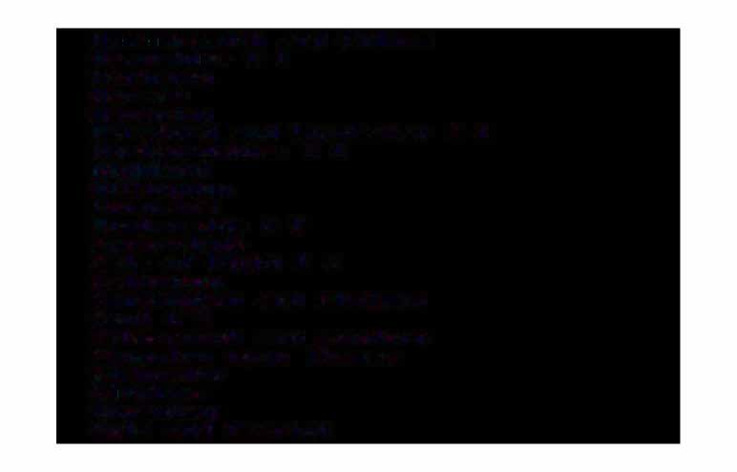Ha,,u·,,ersMith and FulhaM HaMpshit�e C C

Haringey Harrow Havering

HereEord and Worcester C C HertEordshire C C

Highland Hillingdon Hounslow HuMberside C C Inverclyde

Isle oE Wight C C Islington

Kensington and Chelsea Kent C C

KilMarnock and Loudoun Kingston upon ThaMes Kirkcaldy

Kit�klees Knowsley

Kyle and Carrick

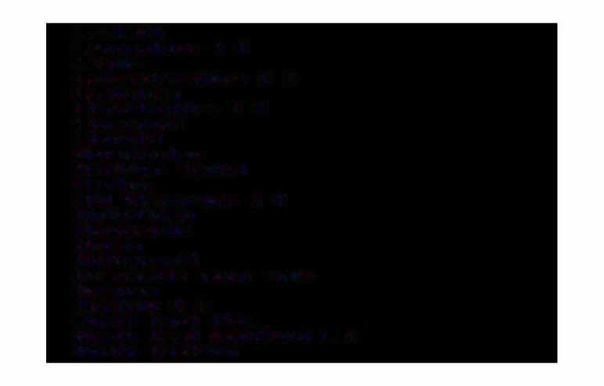LaMbeth Lancashire C C Leeds Leicestershire C C LewishaM Lincolnshire C C Liverpool

Llanelli Manchester Merthyr Tyd-fil Merton

Mid GlaMorgan C C Midlothian Monklands

Moray Motherwell

Newcastle upon Tyne HewhaM

Hor-folk C C Horth East Fi-fe

Horth East Scotland L S Horth Eastern

Hot�th Tyneside Horth Yorkshire C C

HorthaMptonshire C C HorthuMberland C C HottinghaMshire C C OldhaM

Orkney Islands Ox-ford:shire C C

Perth and Kinross Powys C C Redbridge

Ren-frew Rhondda

RichMond upon ThaMes Rochdale

RotherhaM Sal-ford Sandwell Se-fton She-f-field

Shetland Islands Shropshire C C

Solihull SoMerset C C South Eastern

South GlaMorgan C C South Tyneside Southern

Southwark St. Helens

StaEEordshire C C Stirling Stockport Strathkelvin SuEEolk C C Sunderland Surrey C C

Sutton TaMeside Tower HaMlets TraEEord WakeEield Walsall

WalthaM Forest

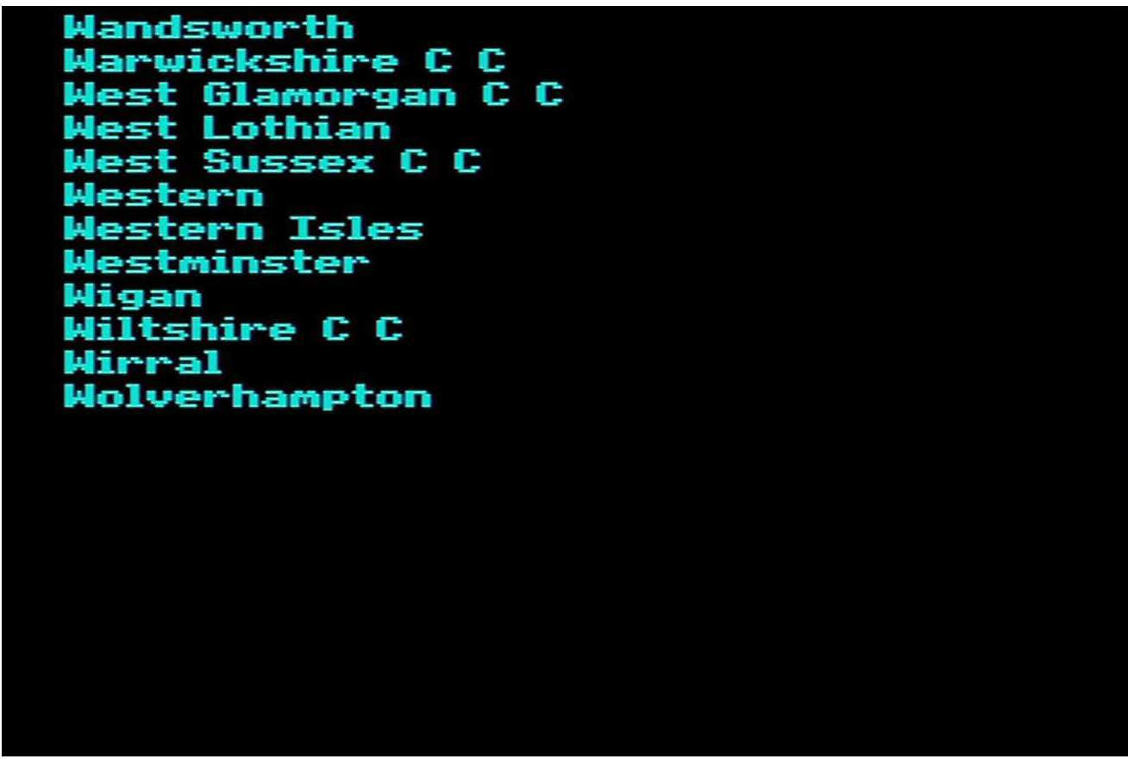

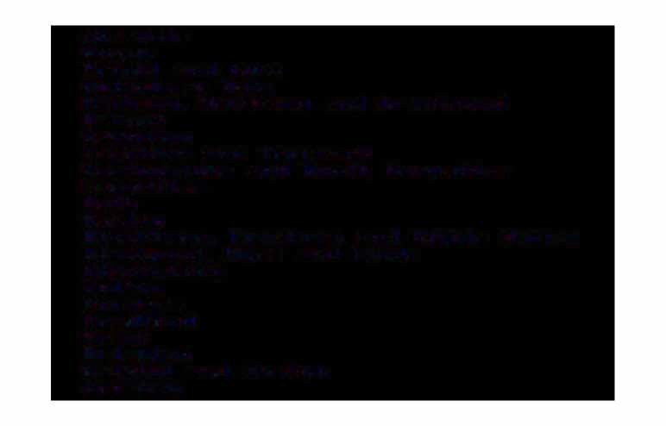Airedale Angus

Argyll and Bute Aylesbury Vale

Barking.. Havering and Brentwood Barnet

Barnsley

Basildon and Thurrock Basingstoke and Horth HaMpshire Bassetlaw

Bath Bexley

Blackburn.. Hyndburn and Ribble Valley Blackpool.. Wyre and Fylde

BlooMsbury Bolton Borders Brad-ford Brent Brighton

Bristol and Weston BroMley

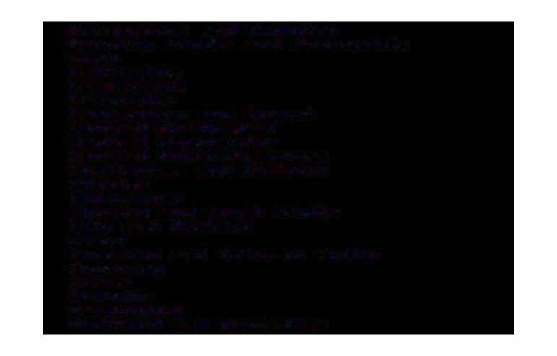BroMsgrove and Redditch Burnley, Pendle and Rossendale Bury

Calderdale CaMberwell CaMbridge

Canterbury and Thanet Central **BirMinghaM** Central Manchester Central HottinghaMshire CheltenhaM and District Chester

Chichester

Chorley and South Ribble City and Hackney

Clwyd

Cornwall and Isles o� Scilly

**Coventry** Crewe Croydon Darlington

Dart�ord and GraveshaM

Dewsbury Doncaster Dudley DuMbarton

DuM-fries and Galloway Dundee

Durhaf'l'II Ealing

East Berkshire East BirMinghaf'l'II East CuMbria East Dorset East Dy-fed

East Fi-fe

East Hert-fordshire East Su-f-folk

East Surrey East Yorkshire Eastbout-ne Eastern

En-field Exeter

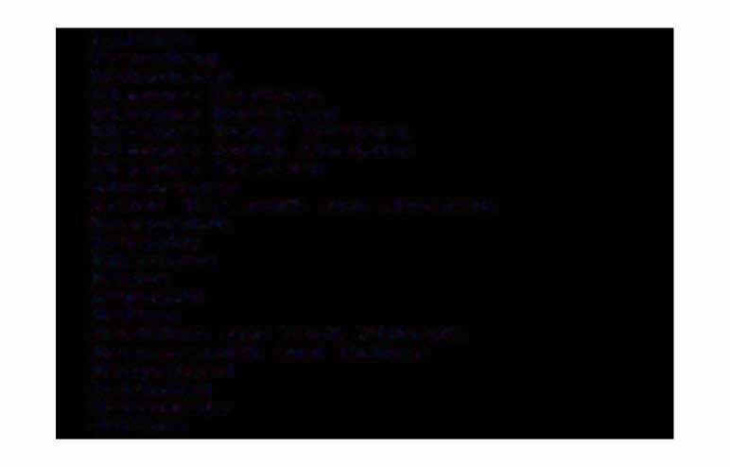Falkirk Frenchay Gateshead Glasgow Eastern

Glasgow Northern Glasgow South Eastern Glasgow South Western Glasgow Western Gloucester

Great YarMouth and Waveney Greenwich

GriMsby Guernsey Gwent Gwynedd Halton

HaMilton and East Kilbride HaMMersMith and FulhaM HaMpstead

Haringey Harrogate Harrow

Hartlepool Hastings

Here-fordshire Hillingdon

Hounslow and Spelthorne Hudders-field

Hull Huntingdon Inverclyde Isle o-f Man Isle o-f Wight Islington Jersey Kettering

KidderMinster and District Kingston and Esher Lancaster

Leeds Eastern Leeds Western Leicestershire

LewishaM and Horth Southwark Liverpool

MacclesEield Maidstone Medway

Merton and Sutton Mid Downs

Mid Essex

Mid GlaMorgan

Mid StaEEordshire Mid Surrey

Milton Keynes

Monklands and CuMbernauld Motherwell and Lanark Newcastle

HewhaM

Horth Ayrshire and Arran Horth BedEordshire

Horth BirMinghaM Horth Derbyshire Horth Devon Horth East Essex Horth GraMpian

Horth HertEordshire

# HHoorrtthh

HLiinghcloalnnsdhsire

HHoo tthh

LMoatnhcihaenster

Horth Staffordshire

Horth Tees

HHoorrtthh

WTyanrewsiicdkeshire

HHoorrtthh

WWeesstt

DHeurrthfaoMrdshire

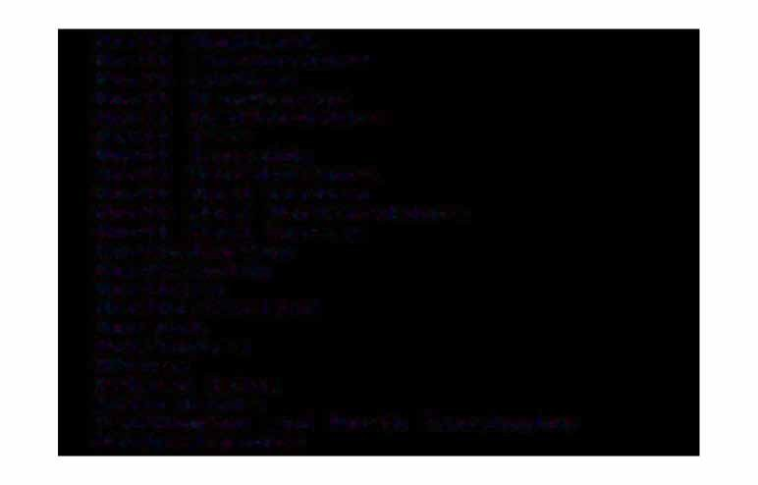Horth West Surrey Horthallerton

HorthaMpton

Northern

HorthuMberland HHoorttwiincghhaM OOlrdkhnaeMy Isles Oxfordshire

Paddington and Horth Kensington PeMbrokeshire

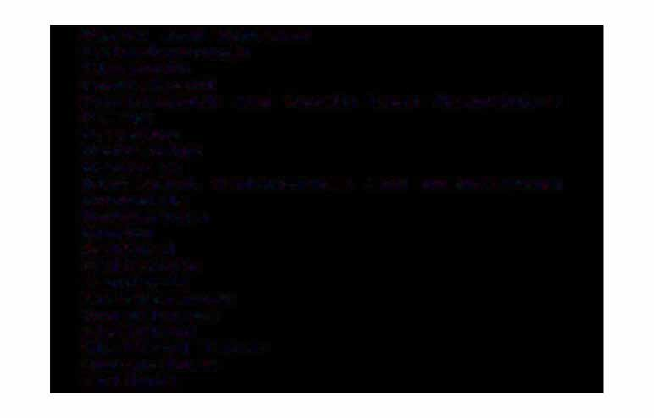Perth and Kinross PPelyttr1eroubtohrough

PPoornttestr1-froauctth and South East Hatr1pshire Powys

PRerdesbrtoidnge Ren-Frew

RRoicchhtr1doanled_. TwickenhaM and Roehatr1pton

Rotherhatr1 Rugby

Sal-ford Salisbury

SScaandrwboerllough SSchuen-f-ftiheolrdpe

Shetland Isles Sht-opshire Solihull

SoMerset

South Ayrshire South Bedfordshire South BirMinghaM South CuMbria South East Kent

South East Staffordshire South GlaMorgan

South GraMpian South Highlands South Lincolnshire South Lothian South Manchester South Se�ton

South Tees South Tyneside

South Warwickshire South West DurhaM

South West Hertfordshire South West Surrey

SouthaMpton and South west HaMpshire Southend

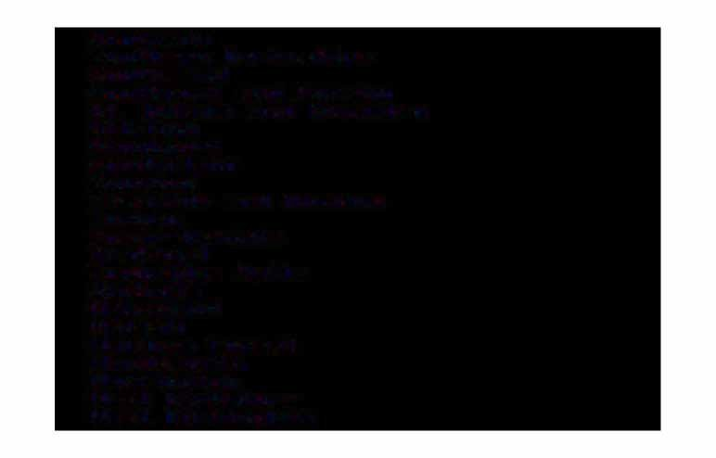Southern

Southern Derbyshire SouthMead

Southport and ForMby St. Helens and Knowsley Stirling

Stockport

**S**S**w**un**in**d**d**e**o**r**n**land

TaMeside and Glossop Torbay

Tower HaMlets Tra-f-ford Tunbridge Wells Uictoria

Wake-field Walsall

WalthaM Forest Wandsworth Warrington West Berkshit-e

West BirMinghaM

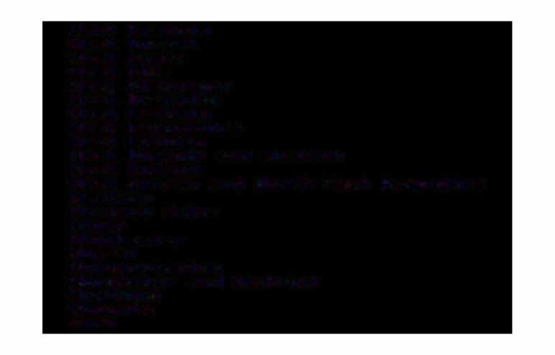West CuMbria West Dorset West Essex West Fife

West GlaMorgan West GraMpian West LaMbeth West Lancashire West Lothian

West Norfolk and Wisbech West Suffolk

West Surrey and Horth East HaMpshire Western

Western Isles Wigan Winchester Wirral WolverhaMpton

Worcester and District Worthing

WycoMbe York

Aberdeen

Aberystwyth Accrington

Aldershot & Farnborough Alloa

AMMan-ford Andover Arbroath Ash-ford Ashington

Ashton 8.: Hyde Aylesbury

Ayr & Prestwick Banbury

Ban-f-f & Buckie Bangor Barnsley

Barnstaple

Barrow-in-Furness Basildon Basingstoke

Bath

Bathgate Bedford Berwick Bideford

Birkenhead & Wallasey BirMinghaM

Bishop Auckland & Aycliffe Bishop's Stortford Blackburn

Blackpool Bolton Boston BourneMouth Bracknell Bradford Braintree Brecon Bridgend Bridgwater Bridlington Brighton Bristol

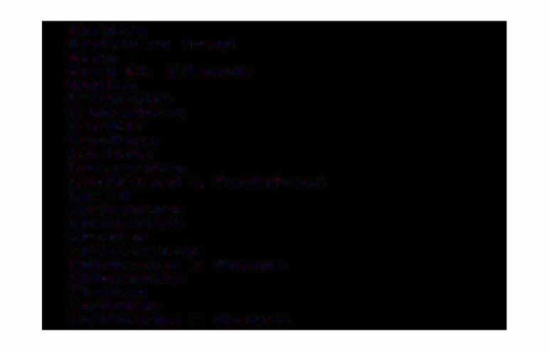Burnley

Burton on tt�ent Bury

Bury St. EdMunds Buxton

CaMbridge Canterbury Cardi-f-f Cardigan Carlisle CarMarthen

Castle-ford & Ponte-fract Chard

ChelMs-fot�d CheltenhaM Chester Chester-field

Chichester & Bognor ChippenhaM

Clacton Coalville

Coatbridge & Airdrie

Colchester Consett Corby Coventry Crawley Crewe

CwMbran & Pontypool Darlington

Deal Derby DerehaM Dewsbut-y Didcot Dingwall Doncaster Dover Dudley DuMbarton DuM-fries Dundee

Dun-ferMline DurhaM

Eastbourne Ebbw Vale Edinburgh Elgin EllesMere Port EveshaM

Exeter Falkirk FalMouth

F-festiniog Folkestone Gelligaet� Glasgow Gloucester Goole

Gosport & FarehaM GranthaM Gravesend Greenock

GriMsby Guild-ford Hali-fax

Harlow Harrogate Hartlepool Hastings Hawick

Haywards Heath Heanor

Heti'llel Heti'llpstead Here-ford

Hert-ford 8.: Ware Hexhati'II

High Wycoti'llbe Hinckley Holyhead Horshati'II Hudders-field Hull Huntingdon Inverness: Ipswich Irvine

Isle o-f Wight

Keighley Kendal Kettering KidderMinster KilMarnock Kings Lynn Kirkcaldy Lanark Lancaster Launceston LeaMington Leeds

Leek Leicester Leigh Letchworth

Leyland & Chorley Lincoln

Liverpool Llandudno Llanelli London

Loughborough Lowesto-ft Luton

Maccles-field Maidenhead Maidstone Malvern Manchester Mans-field

Margate & RaMsgate Matlock

Medway Towns Melton Mowbray Merthyr Tyd-fil Mexborough Middlesbrough Milton Keynes MonMouth Motherwell Heath

Helson & Colne Newark

Newbury

Newcastle-upon-Tyne HewMarket

Newport Newton Abbot Horthallerton HorthaMpton Horthwich Horwich HottinghaM Ohan

OldhaM Ox-ford Paisley PeMbroke Penrith Penzance Perth

Peterborough Peterhead Petet-lee PlyMouth

Pontypridd Port Talbot PortsMouth Preston Reading Redditch

Redruth & CaMborne Reigate & Redhill Rhyl & Prestatyn Rochdale

Rossendale RotherhaM Rugby Salisbury Scarborough Scunthorpe She-f-field Shotton Shrewsbury

Sittingbourne & Milton Regis Slough

SMethwick

# South Shields

SSoouutthhaeMndpton

Southport

SStp.alAdlibnagns

SStt.. AAunsdtreelwls

SStta. -fH-feolredns

StaM-ford

Stevenage Stirling Stockport Stockton-on-Tees SSttoorkenoownaytrent

SSttrraant-froaredr-on-Avon Stroud

Sunderland Swansea

Swindon TaMworth Taunton Tel-ford Thet-ford Thurso Tiverton Torquay Trowbridge Truro

Tunbridge Wells Wake-field Walsall Warrington

Wat-ford Wellingborough Wells Welshpool Welwyn

West BroMwich Weston-Super-Mare WeyMouth

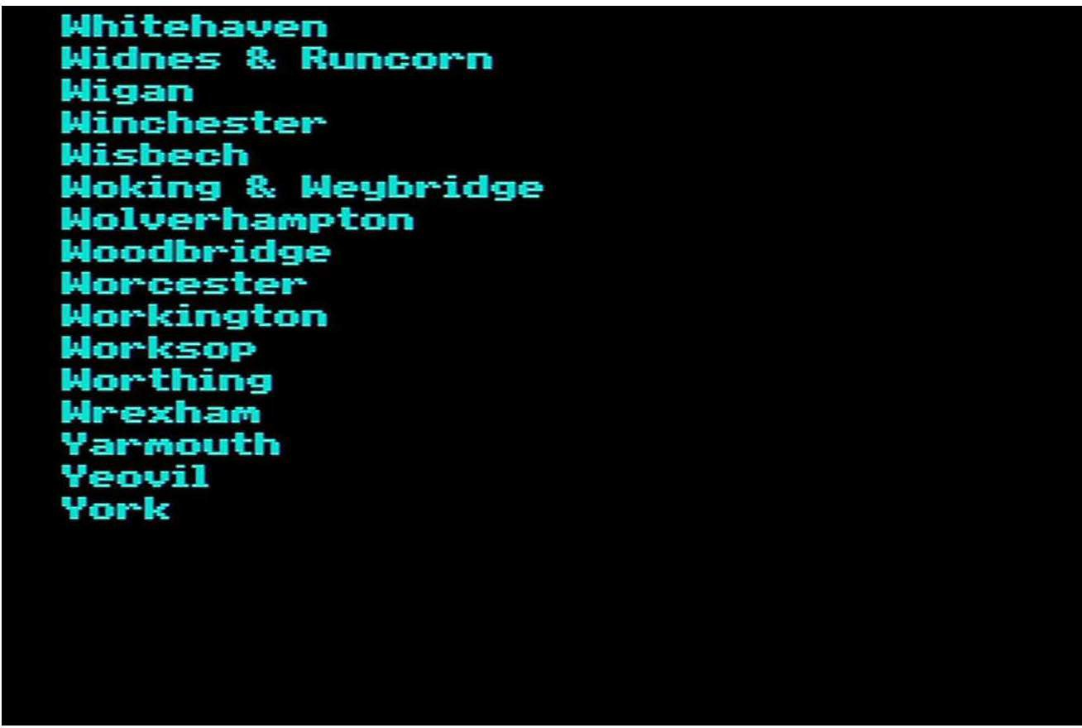

Aberdare Aberdeen Aberystwyth

Accrington and Rossendale AlEreton and AshEield Alloa

Alnwick and AMble Andover

**Annan** Arbroath AshEot-d

Aylesbury and WycoMbe Ayr

Badenoch BallyMena Banbury BanEE

Bangor and CaernarEon Barnsley

Barnstaple and IlEracoMbe Barrow-in-Furness Basingstoke and Alton

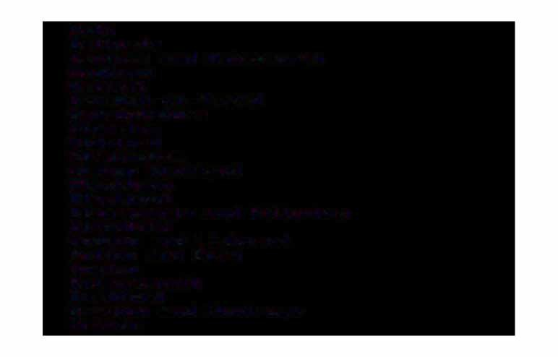Bath Bathgate

Beccles and Halesworth BedEord

BelEast

Berwick-on-Tweed Berwickshire Bicester

BideEord BirMinghaM Bishop Auckland Blackburn Blackpool

Blairgowrie and Pitlochry BlandEord

BodMin and Liskeard Bolton and Bury Boston

BourneMouth BradEord

Brechin and Montrose Brecon

Bridgend Bridgwater

Bridlington and DriEEield Bridport

Brighton Bristol Buckie Bude Burnley

Burton-on-Trent Bury St. EdMonds Buxton

Calderdale CaMbridge CaMpbeltown Canterbury CardiE� Cardigan Carlisle CarMarthen

CastleEord and PonteEract Chard

ChelMs�ord and Braintree CheltenhaM

Chester�ield Chichester ChippenhaM

Cinder�ord and Ross-on-Wye Cirencester

Clacton Clitheroe Colchestet- Coleraine

Conwy and Colwyn Cookstown

Corby

Coventry and Hinckley Craigavon

Crawley Crewe Ct-ie��

CroMer and Horth WalshaM CuMnock and Sanquhar Darlington

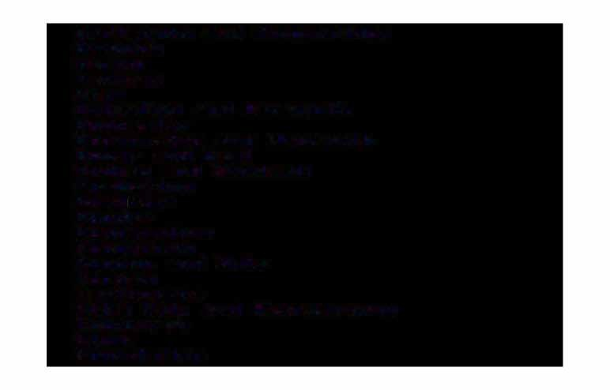DartMouth and Kingsbridge Denbigh

Derby Devizes Diss

Dolgellau and BarMouth Doncaster

Dorchester and We,yMouth Dover and Deal

Dudley and Sandwell DuMbarton

DuM-ft�ies Dundee

Dun-ferMline Dungannon Dunoon and Bute Durh.aM Eastbourne

Ebbw Vale and Abergavenny Edinburgh

Elgin Enniskillen

EveshaM Exeter FakenhaM Falkirk FalMouth Fishguard Folkestone For-far Forres: Fras:erburgh Gainsborough Galas:hiels: Girvan Glasgow Gloucester

Goole and Selby Gosport and FarehaM GranthaM

Great YarMouth Greenock GriMs:by

Guild-ford and Alders:hot

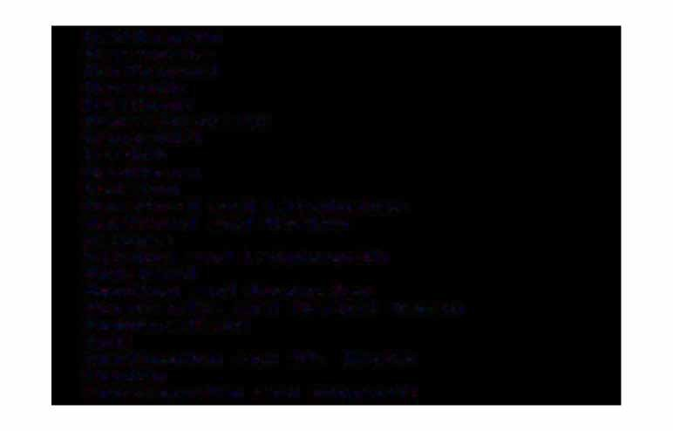Haddington Harrogate Hartlepool Harwich Hastings Haverf=ordwest Haverhill Hawick Heathrow Helston

Heref=ord and LeoMinster Hertf=ord and Harlow HexhaM

Hitchin and Letchworth Holyhead

Honiton and AxMinster Horncastle and Market Rasen Huddersf=ield

Hull

Huntingdon and St. Heots Huntly

Invergordon and Dingwall

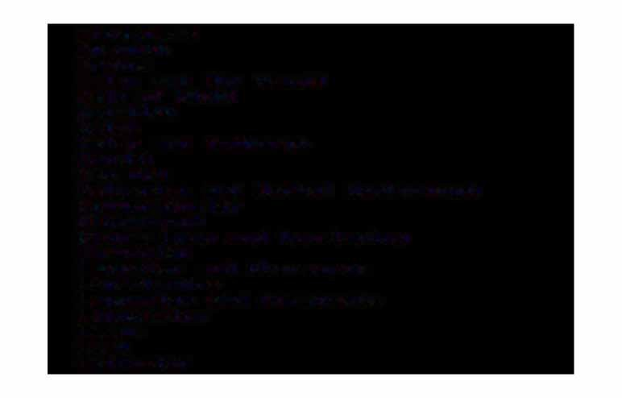Inverness Ipswich Irvine

Islay and Mid Argyll Isle o-f Wight Keighley

Keith

Kelso and Jedburgh Kendal

Keswick

Kettering and Market Harborough KidderMinstet-

KilMarnock

King�s Lynn and Hunstanton Kirkcaldy

LaMpeter and Aberaeron Lanarkshire

Lancaster and MorecaMbe Launceston

Leeds Leek Leicester

Lincoln Liverpool Llandeilo Llandrindod Wells Llanelli Lochaber Lockerbie **L**Lo**o**n**n**d**d**o**o**n**n**derry

Loughborough and Coalville Louth and Mablethorpe Lowesto-ft

Ludlow Maccles-field Machynlleth Maghera-felt Malton

Malvern and Ledbury Manchester

Mans-field Matlock

Medway and Maidstone

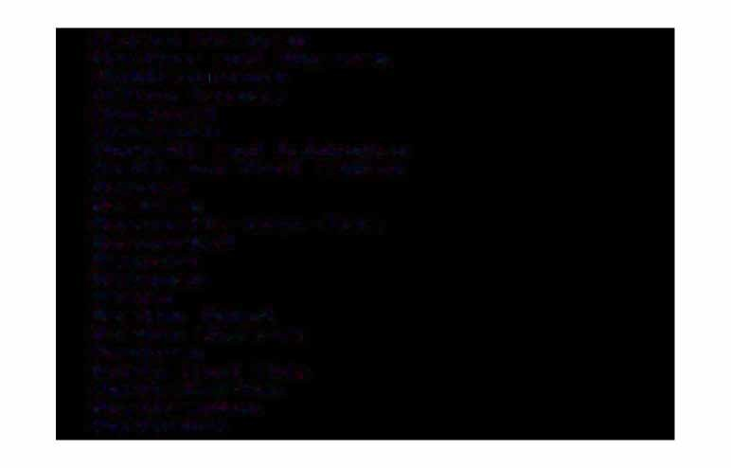Melton Mowbray Merthyr and RhyMney Middlesbt�ough

Milton Keynes Minehead MonMouth

Morpeth and Ashington Heath and Port Talbot Newark

Newbury

Newcastle-upon-Tyne HewMarket

Newport Hewquay Newry

Newton Abbot Newton Stewart Newtown

Horth East Fi-fe Horthallerton HorthaMpton Horthwich

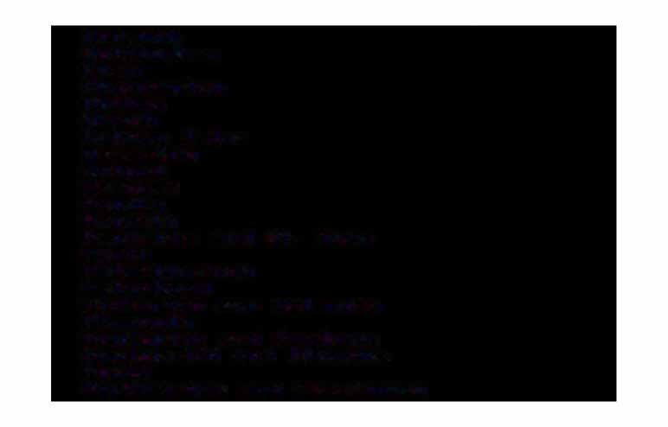Horwich HottinghaM Ohan OkehaMpton OldhaM OMagh

Orkney Isles Oswestry

Ox-ford Peebles Pendle Penrith

Penzance and St. Ives Perth

Peterborough Peterhead

Pickering and HelMsley PlyMouth

Pontypool and CwMbran Pontypridd and Rhondda Poole

PorthMadoc and F-festiniog

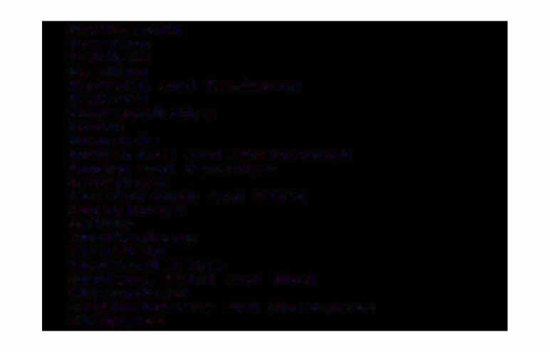Pot�tsf'l'llouth Preston Pwllheli Reading

Redruth and Caf'l'!lborne Ret-ford

Richf'l'llondshire Ripon Rochdale

Rotherhaf'l'II and Mexborough Rugby and Daventry Salisbury

Scarborough and Filey Scunthorpe

Settle

Sha-ftesbury She-f-field Shetland Isles

Shotton, Flint and Rhyl Shrewsbury

Sittingbourne and Sheerness Skegness

Skipton

Skye and Wester Ross Sleaf'.ord

Slough

South Molton

South PeMbrokeshire South Tyneside SouthaMpton Southend

Spalding and Holbeach St. Austell

Staf'.f'.ord StaMf'.ord Stewartry Stirling

Stockton-on-Tees Stoke

Strabane Strant�aer Stroud Sudbury Sunderland

Sutherland Swansea Swindon Taunton

Tel�ord and Bridgnorth Thanet

Thet�ord Thirsk Thurso Tiverton Torbay Torrington Totnes

Trowbridge and FroMe Truro

Tunbt-idge Wells Uttoxeter and Ashbourne Wake�ield and Dewsbury Walsall

WarehaM and Swanage WarMinstet­ Warrington

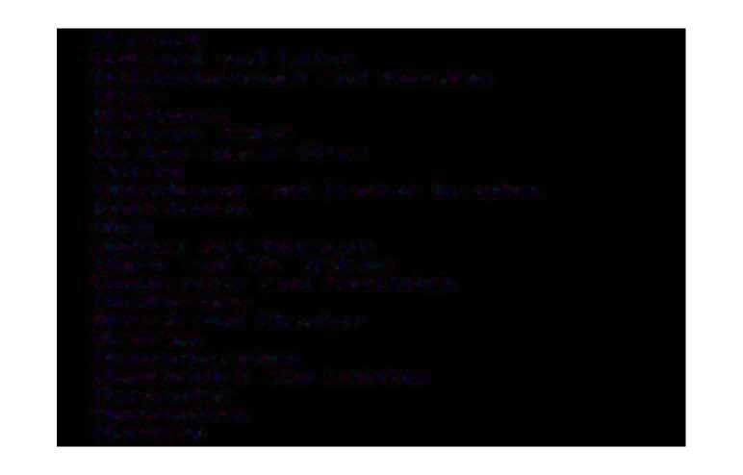Warwick

Watford and Luton Wellingbot�ough and Rushden Wells

Welshpool Western Isles

Weston-super-Mare Whitby

Whitchurch and Market Drayton Whitehaven

Wick

Widnes and Runcorn Wigan and St. Helens Winchester and Eastleigh Winderti'lere

Wirral and Chester Wisbech Wolverhati'lpton

Woodbridge and Leiston Worcester

Workington Worksop

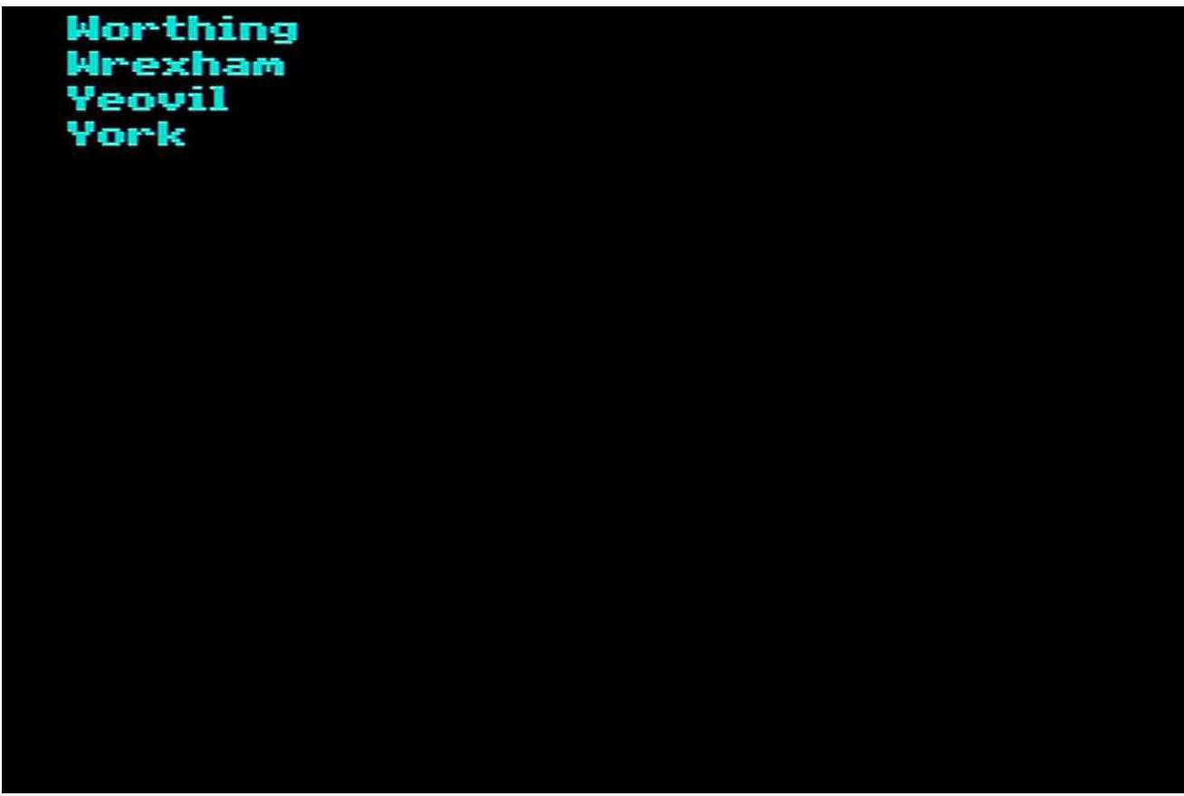

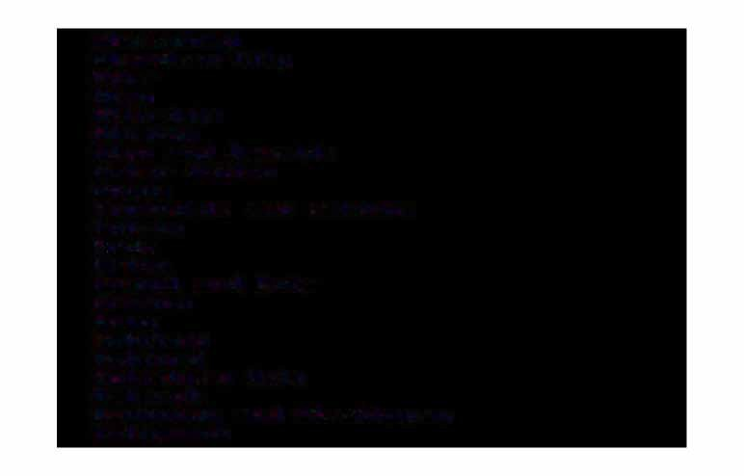Aberconwy Aberdeen City Adur

A-fan Allerdale Alnwick

Alyn and Deeside AMber Ualley Angus

Annandale and Eskdale Antrif'l'l

At�ds Ar-fon

Argyll and Bute ArMagh

**Arun** Ash-field Ash-ford

Aylesbury Uale Babergh

Badenoch and Strathspey Ballyf'l'lena

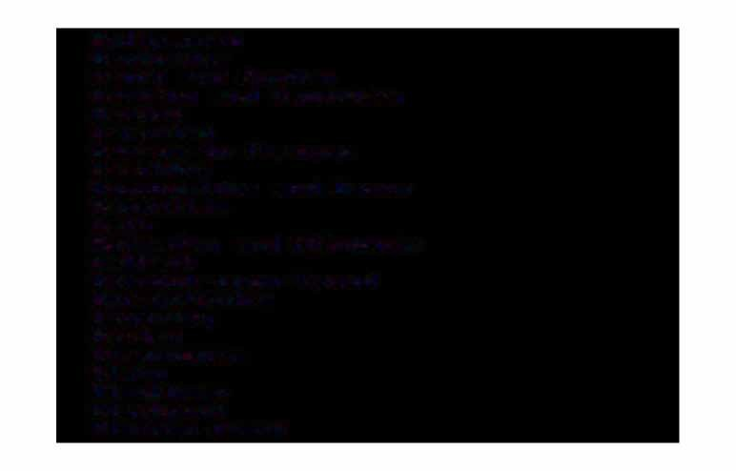BallyMoney Banbridge

Ban�� and Buchan Barking and DagenhaM Barnet

Barnsley

Barrow-in-Furness Basildon

Basingstoke and Deane Bassetlaw

Bath

Bearsden and Milngavie Bel�ast

Berwick-upon-Tweed Berwickshire Beverley

Bexley BirMinghaM Blaby Blackburn Blackpool Blaenau Gwent

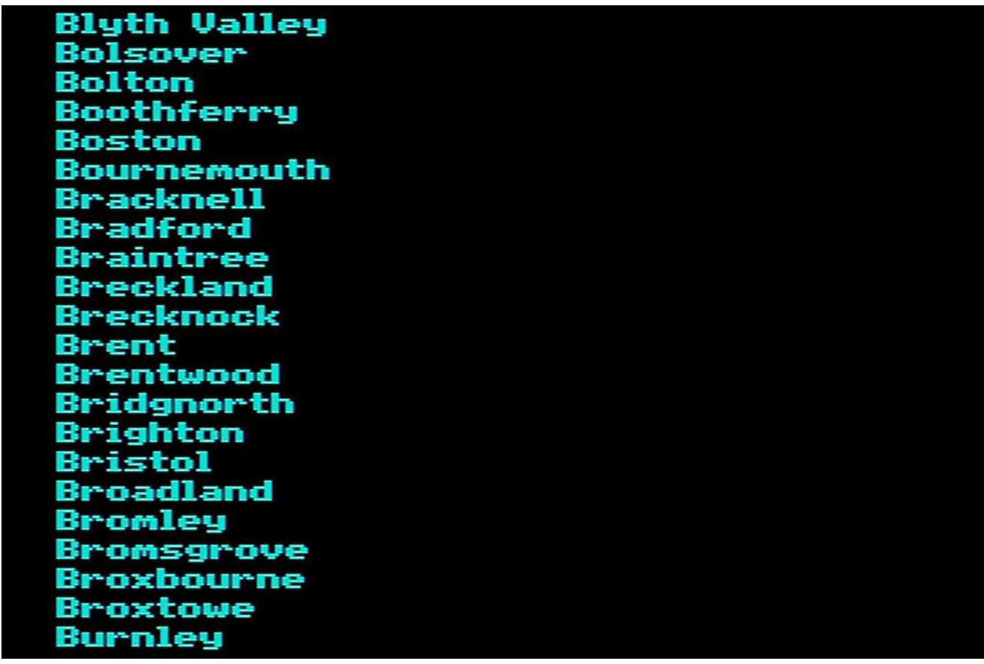

Bury Caithness Calderdale CaMbridge Caf'!'llden

Cannock Chase Canterbury Caradon

Cardi-f-f Carlisle CarMarthen Cat-rick Carrick-fergus

Castle Morpeth Castle Point Castlereagh Ceredigion Charnwood ChelMs-ford Cheltenhaf'l'II Cherwell Chester

Chester-le-Street Chester-Field Chichester Chiltern

Chorley Christchurch City of' London Clacktl'lannan Cleethorpes Clydebank Clydesdale Colchester Coleraine Colwyn Congleton Cookstown Copeland

Corby Cotswold Coventry Ct-aigavon Craven

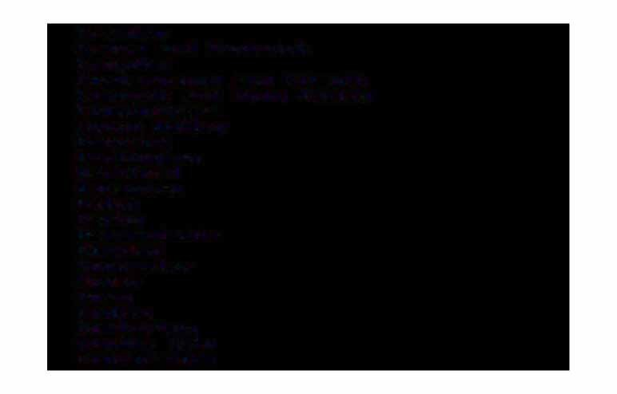Crawley

Crewe and Nantwich Croydon

CuMbernauld and Kilsyth CuMnock and Doon Valley CunninghaMe

Cynon Valley DacoruM Darlington Dartf'ord Daventry Delyn

Derby Derwentside Dinef'wr Doncaster Dover

Down Dudley DuMbarton Dundee City Dunf'erMline

Dungannon DurhaM Dwyf'or Ealing Easington

East CaMbridgeshire East Devon

East HaMpshire East Hertf'ordshire East Kilbride

East Lindsey East Lothian

East HorthaMptonshire East Staf'f'ordshire East Yorkshire Eastbourne

Eastleigh Eastwood Eden

Edinburgh City

EllesMere Port and Heston ElMbridge

En-field

Epping Forest EpsoM and Ewell Erewash

Ettrick and Lauderdale Exeter

Falkirk FarehaM Fenland Fertr1anagh Forest Heath Forest o-f Dean Fylde Gateshead Gedling GillinghaM

Gian-ford Glasgow City Gloucester Glyndwr Gordon Gosport

Graveshati'II Great GriMisby Great Yarti'llouth Greenwich Guernsey Guildf=ord Hackney

Halton HaMibleton HaMiilton

Hati'llti'llet�sti'llith and Fulhati'II Harborough

Haringey Harlow Harrogate Harrow Hart Hartlepool Hastings Havant Havering Heref=ord

Het�tsMere High Peak Hillingdon

Hinckley and Bosworth Holderness

HorshaM Hounslow Hove Huntingdon Hyndburn Invet�clyde Inverness Ipswich

Isle o-f Anglesey Isle o-f Man Isles o-f Scilly Islington

Islwyn

.Jersey Kennet

Kensington and Chelsea Kerrier

Kettering

KilMarnock and Loudoun Kincardine and Deeside Kingston upon Hull Kingston upon ThaMes Kingswood

Kirkcaldy Kirklees Knowsley

Kyle and Carrick LaMbeth Lancaster Langbaurgh Larne

Leeds Leicester LeoMinster Lewes LewishaM Lich-field LiMavady Lincoln

Lisburn Livet-pool Llanelli Lliw Valley Lochaber

Londonderry Luton Macclest=ield Magherat=elt Maidstone Maldon Malvern Hills Manchester Manst=ield Medina Meirionnydd Melton Mendip

Merthyr Tydt=il Merton

Mid Bedt=ordshire Mid Devon

Mid Suf'f'olk Mid Sussex Middlesbt�ough Midlothian Milton Keynes Mole Valley Monklands Monf'!'llouth Montgof'!'llery Moray Motherwell Moyle

Hairn Heath

Hew Forest Newark Newbury

Newcastle upon Tyne Hewcastle-under-Lyf'!'lle Hewhaf'l'II

Newport

Hewry and Mourne

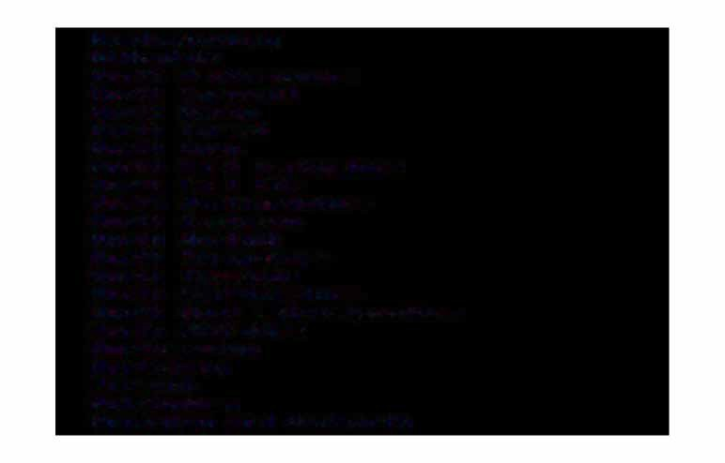**Newtownabbey**

Hithsdale

**Horth** Bedfordshire **Horth Cornwall Horth Devon**

**Horth** Dorset

**Horth Down**

**Horth** East Derbyshire

**Horth** East Fife **Horth** Hertfordshire **Horth** Kesteven **Horth** Norfolk

**Horth** Shropshire **Horth** Tyneside **Horth** Warwickshire

**Horth** West Leicestershire Horth Wiltshire **HorthaMpton**

Horthavon **Horwich HottinghaM**

Nuneaton and Bedworth

Oadby and Wigston Ogwr

OldhaM OMagh

Orkney Isles Oswestry Oxt=ord **P**P**e**en**nw**dl**i**e**th**

Perth and Kinross

Peterborough PlyMouth Poole PortsMouth Preseli Preston Purbeck Radnor Reading

Redbt-idge Redditch

Reigate and Banstead

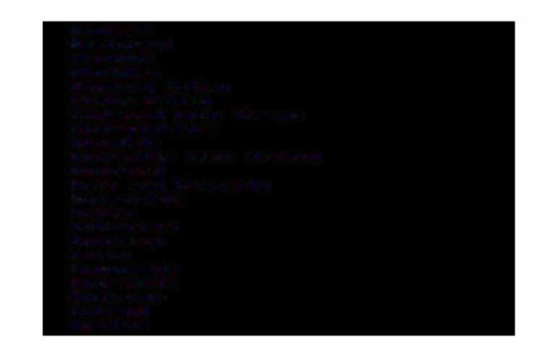Ren-frew RestorMel Rhondda Rhuddlan RhyMney Valley Ribble Valley

RichMond upon ThaMes RichMondshire Rochdale

Rochester upon Medway Roch-ford

Ross and CroMarty Rossendale

Rother RotherhaM Roxburgh Rugby RunnyMede Rushcli-f-fe RushMoot� Rutland Ryedale

Salf=ord Salisbury Sandwell Scarborough Scunthorpe Sedgef=ield Sedgef'!'lloor Sef=ton

Selby Sevenoaks Shef=t=ield Shepway Shetland Isles

Shrewsbury and Atchaf'l'II Skye and Lochalsh Slough

Solihull

South Bedf=ordshire South Bucks

South Caf'!'llbridgeshire South Derbyshire South Haf'!'lls

# South Herefordshire

SSoouutthh

KHeolsltaenvden

SSoouutthh LNaorkfeolalknd

South HorthaMptonshire

SSoouutthh SSoouutthh

POexEMobrrdoskheisrheire SRhibrbolpeshire

South Staffordshire

South Tyneside South Wight SouthaMpton Southend-on-Sea

S

Sopueltthhwoarrnke

SStt..

AEdlbMaunnsdsbur,y

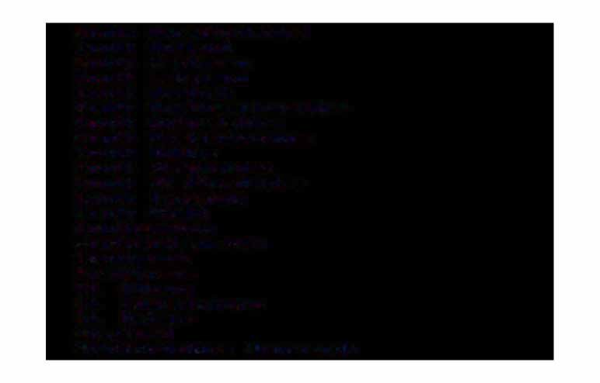St. Helens Stafford

Staffordshire Moorlands

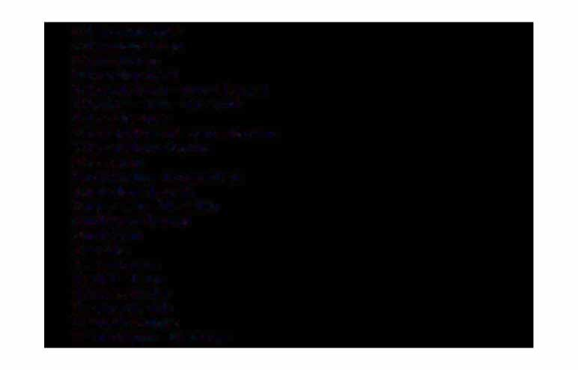SStteewveanratgrey SSttoirclkipnogrt

Stockton-on-Tees Stoke-on-Trent

Strabane

StratEord-on-Avon Strathkelvin SSutrEEoouldk Coastal Sunderland

Surrey Heath Sutherland Sutton SSwwaanlesea

TTaaEMEe-sEildye

TTaaMndwroirdtghe Taunton Deane

Teesdale Teignbridge Tendring Test Valley Tewkesbury ThaMesdown Thanet

The Wrekin Three Rivers Thurrock

Tonbridge and Malling Torbay

Tor-faen Torridge Tower HaMlets Tra-f-ford

Tunbridge Wells Tweeddale Tynedale

Uttles-ford

Vale o-f GlaMorgan Vale o-f White Horse

Uale Royal Wake-field Walsall

WalthaM Forest Wandsworth Wansbeck Wansdyke Warrington Warwick

Wat-ford Waveney Waverley Wealden Wear Valley

Wellingborough Welwyn Hat-field West Derbyshire West Devon

West Dorset West Lancashire West Lindsey West Lothian

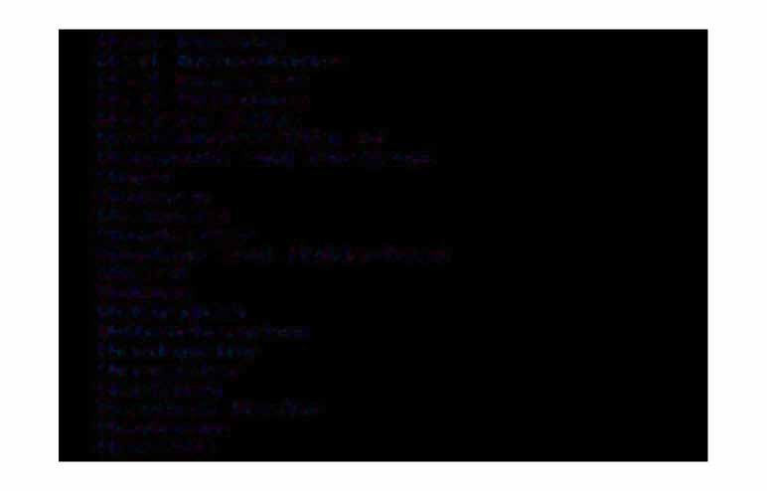West Norfolk West Oxfordshire West SoMerset West Wiltshire Western Isles

WestMinster.City of WeyMouth and Portland Wigan

**Wigtown** WiMborne Winchester

Windsor and Maidenhead Wirral

Woking WokinghaM WolverhaMpton Woodspring Worcester Worthing WrexhaM Maelor Wychavon WycoMbe

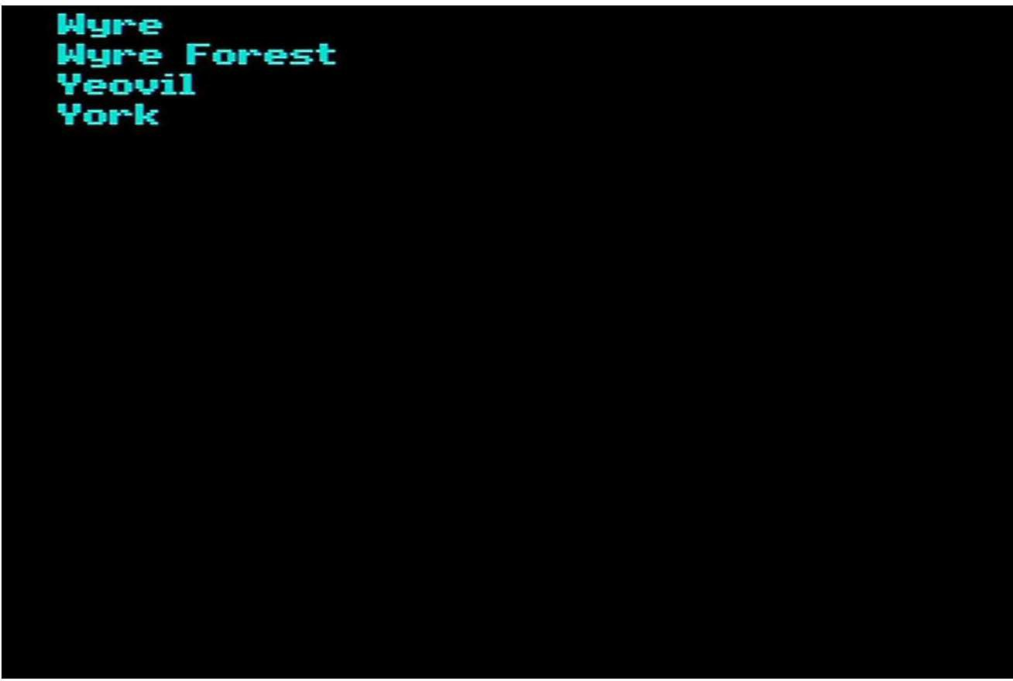

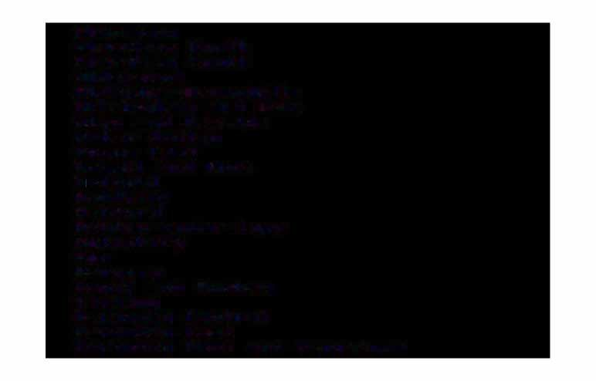Aberavon Abet�deen Horth Aberdeen South Aldershot

Aldridge-Brownhills AltrinchaM and Sale Alyn and Deeside AMber Valley

Angus East Argyll and Bute At�undel

Ash-field Ash-ford

Ashton-under-Lyne Aylesbury

Ayr Banbury

Ban-f-f and Buchan Barking

Barnsley Central Barnsley East

Barnsley West and Penistone

Barrow and Furness Basildon Basingstoke Bassetlaw

Bath

Batley and Spen Batter:sea Beacons-field BeckenhaM

Berwick-upon-Tweed Bethnal Green and Stepney Beverley

Bexhill and Battle Bexley Heath Billericay Birkenhead

BirMinghaM Edgbaston BirMinghaM Erdington BirMinghaM Hall Green BirMinghaM Hodge Hill BirMinghaM Ladywood BirMinghaM Horth-field

BirMinghaM Perry Barr BirMinghaM Selly Oak BirMinghaM SMall Heath BirMinghaM Sparkbrook BirMinghaM Yardley Bishop Auckland

Blaby Blackburn

Blackpool Horth Blackpool South Blaenau Gwent Blaydon

Blyth Valley Bolsover

Bolton Horth East Bolton South East Bolton West

Booth Ferry Bootle Boswot-th

BourneMouth East BourneMouth West

BBto-awdaf'onrddPHooprlathr

Bradf'ord South

Bradf'ord West Braintree BBrreenctonEaasntd Radnor

Brent

**Horth**

Brent South

BBrreennttwf'oorodd aanndd IOsnlgeawrorth

Bridgend Bridgwater Bridlington

BBrriigghgtaonndKeCMlepettohwonrpes

Brighton Pavilion

BBrriissttooll

HEaorstth West

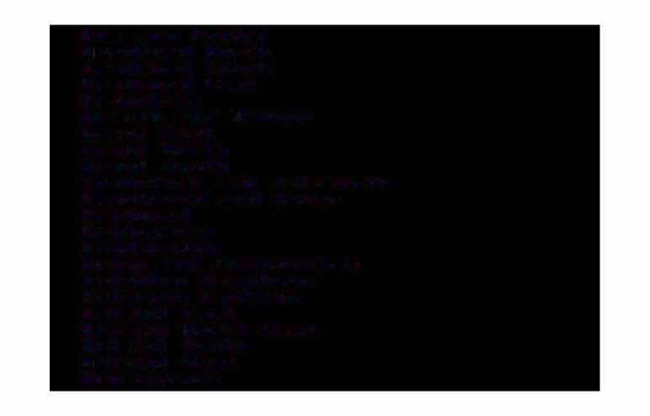Bristol South Bt-istol West BroMsgrove

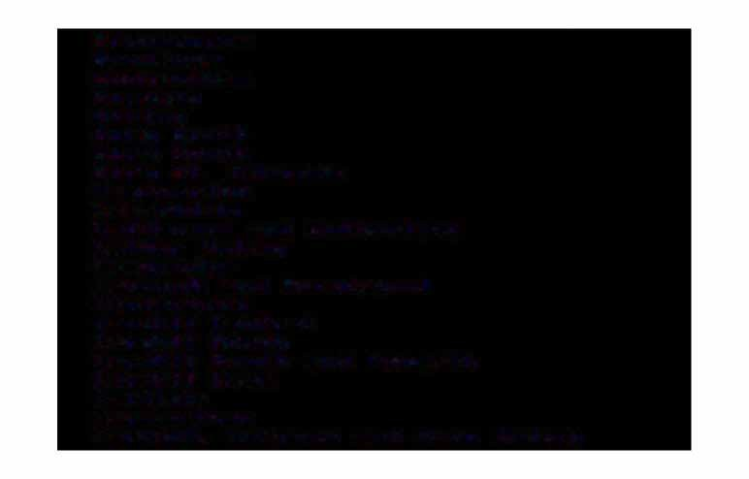Broxbourne Broxtowe Buckinghafl'II Burnley Burton Bury Horth Bury South

Bury St. EdMunds Caernar-fon Caerphilly

Caithness and Sutherland Calder Valley

CaMbridge

Cannock and Burntwood Canterbury

Cardi-f-f Central Cardi-f-f Horth

Cardi-f-f South and Penarth Cardi-f-f West

Carlisle CarMarthen

Carrick., CuMnock and Doon Valley

# Carshalton and Wallington CCeasnttrlealPoFii�net

CCeernetrdaigl ioSun�a�onldk PeMbroke Horth Cheadle

CChheellsMesa�ord

CheltenhaM CChheersthsaeMy aanndd AWMaelrtsohnaM Chester�ield Chichester

ChingEord Chipping Barnet Chislehurst

Chorley

Christchurch

Cirencester and Tewkesbury City o� Chester

City o� DurhaM

City o� London and WestMinster South

ClackMannan Clwyd Horth West Clwyd South West

Clydebank and Milngavie Clydesdale

Colne Valley Congleton Conwy Copeland

Corby

Coventry Coventry Coventry Coventry

Crawley

Horth Horth South South

East West East West

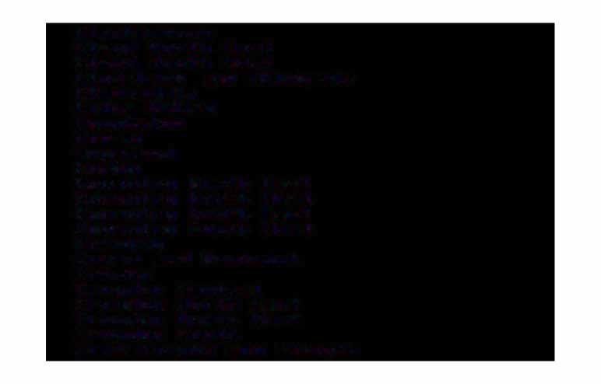Crewe and Nantwich Crosby

Croydon Central Croydon Horth East Croydon Horth West Croydon South

CuMbernauld and Kilsyth

CunninghaMe Horth CunninghaMe South Cynon Valley DagenhaM Darlington Dartf=ord

Daventry DavyhulMe Delyn

Denton and Reddish Derby Hot�th

Derby South Devizes Dewsbury Don Valley

Doncaster Central Doncaster Horth Dover

Dudley East Dudley West Dulwich DuMbarton

DuM-fries Dundee East Dundee West

Dun-ferMline East Dun-ferMline West Ealing Acton Ealing Horth Ealing Southall Easington

East Berkshire East HaMpshire East Kilbride East Lindsey East Lothian East Surrey Eastbourne Eastleigh Eastwood Eccles Eddisbury

Edinburgh Central Edinburgh East

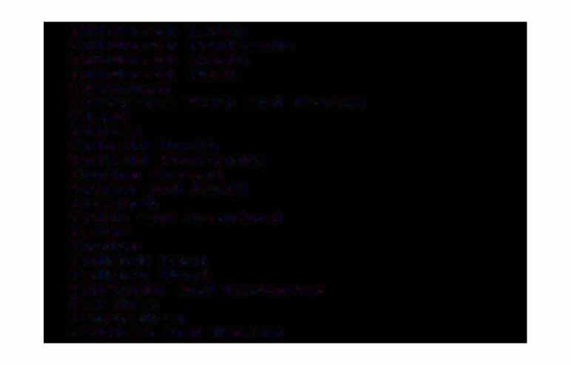Edinburgh Leith Edinburgh Pentlands Edinburgh South Edinburgh West Edtl'lonton

Ellestl'lere Port and Heston Eltl'let

Elthatl'I

En-field Horth

En-field Southgate Epping Forest Epsotl'I and Ewell Erewash

Erith and Cray-ford Esher

Exeter Falkirk East Falkirk West

Faltl'louth and Catl'lborne Farehatl'I

Favershatl'I

Felthatl'I and Heston

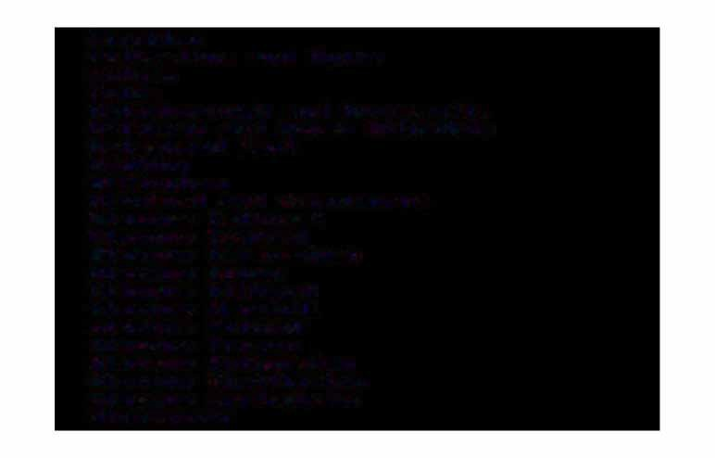Finchley

Folkestone and Hythe FulhaM

Fylde

Gainsborough and Horncastle Galloway and Upper Hithsdale Gateshead East

Gedling GillinghaM

Glanford and Scunthorpe Glasgow Cathcart Glasgow Central

Glasgow Garscadden Glasgow Govan Glasgow Hillhead Glasgow Maryhill Glasgow Pollock Glasgow Provan Glasgow Rutherglen Glasgow Shettleston Glasgow Springburn Gloucester

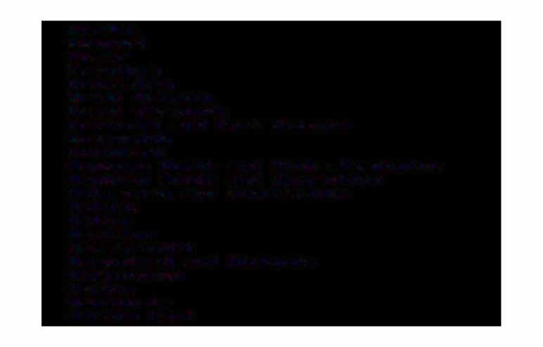Gordon Gosport Gower GranthaM GraveshaM

Great GriMsby Great YarMouth

Greenock and Port Glasgow Greenwich

Guild-ford

Hackney Horth and Stoke Hewington Hackney South and Shoreditch Halesowen and Stourbridge

Hali-fax

**H**Ha**a**l**M**t**i**o**l**n**ton**

HaMMers:Mith

HaMpstead and Highgate Harborough

Harlow Harrogate Harrow East

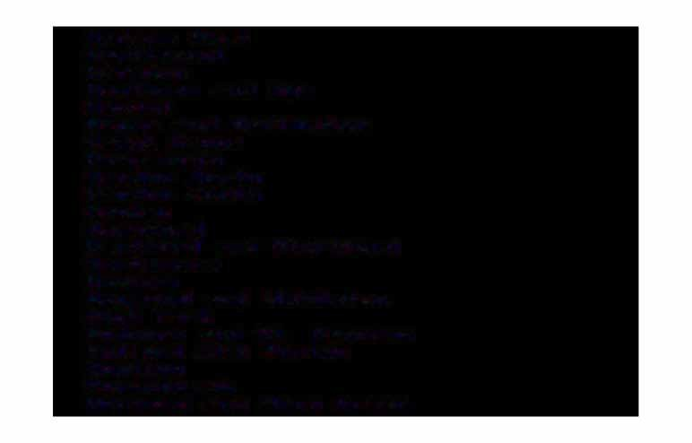Harrow West Hartlepool Harwich

Hastings and Rye Havant

Hayes and Harlington Hazel Grove Hef'!'llsworth

Hendon Horth Hendon South Henley

Here-f=ord

Hert-f=ord and Stort-f=ord Hertsf'!'llere

Hexhaf'l'II

Heywood and Middleton High Peak

Holborn and St. Pancras Holland with Boston Honiton

Hornchurch

Hornsey and Wood Green

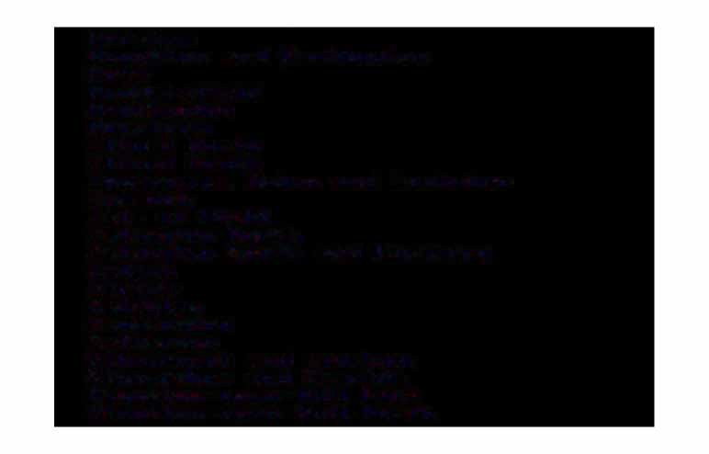HorshaM

Houghton and Washington Hove

Hudders-field Huntingdon Hyndburn

II-ford Horth II-ford South

Inverness_. Hairn and Lochaber Ipswich

Isle o-f Wight Islington Horth

Islington South and Finsbury Islwyn

.Jarrow Keighley Kensington Kettering

KilMarnock and Loudoun Kincardine and Deeside Kingston-upon-Hull East Kingston-upon-Hull Horth

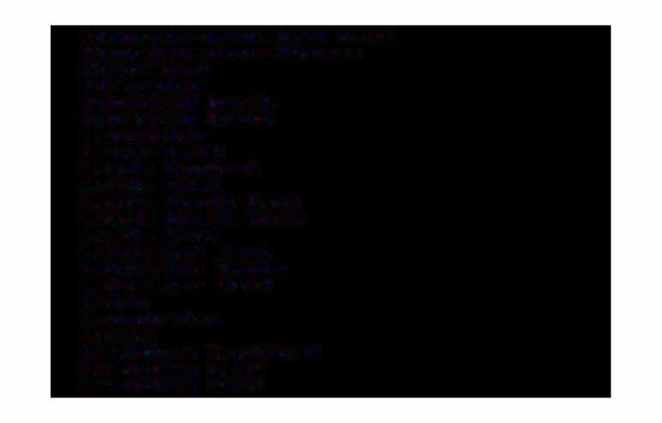Kingston-upon-Hull West Kingston-upon-ThaMes Kingswood

Kirkcaldy Knowsley Horth Knowsley South Lancaster Langbaurgh Leeds Central Leeds East

Leeds Horth East Leeds Horth West Leeds West Leicester East Leicester South Leicester West Leigh

LeoMinster Lewes

LewishaM DeptEord LewishaM East LewishaM West

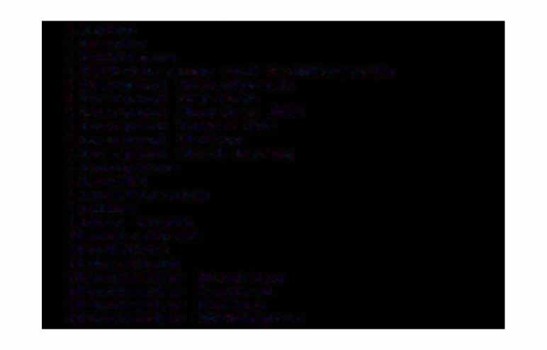Leyton Lincoln Linlithgow

Littleborough and Saddleworth Liverpool Broadgreen Liverpool Garston

Liverpool Mossley Hill Liverpool Riverside Liverpool Walton Liverpool West Derby Livingston

Llanelli Loughborough Ludlow

Luton South Maccles-field Maidstone Maker-field

Manchester Blackley Manchester Central Manchester Gorton Manchester Withington

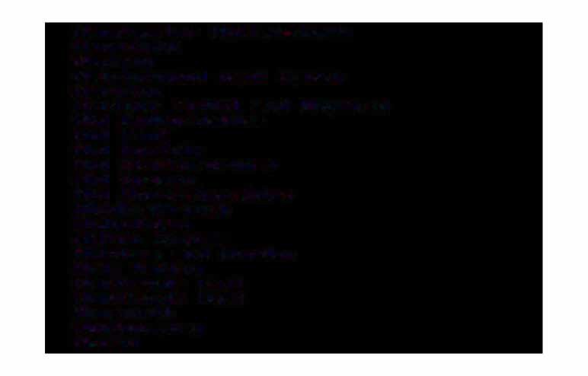Manchester Wythenshawe Mans-field

Medway

Meirionnydd nant Conwy Meriden

Merthyr Tyd-fil and RhyMney Mid Bed-fordshire

**Mid Kent**

Mid Hor-folk

Mid Sta-f-fordshire

**Mid** Sussex

Mid Worcestershire Middlesbrough Midlothian

Milton Keynes Mitchatl'I and Morden Mole Ualley Monklands East Monklands West Montl'louth Montgotl'lery

Moray

MorecaMbe and Lunesdale Morley and Leeds South Motherwell Horth Motherwell South

Heath

**Hew** Forest **Newark Newbury**

**Hewcastle-under-LyMe** Newcastle-upon-Tyne Central Newcastle-upon-Tyne East Newcastle-upon-Tyne **Horth HewhaM Horth** East

**HewhaM Horth** West **HewhaM South Newport** East **Newport** West **HorManton**

**Horth** Bedfordshire **Horth** Colchester **Horth Cornwall Horth** Devon

# HHoorrtthh DDourrshateM

Horth East CaMbridgeshire Horth East Derbyshire Horth East FiEe

Horth HertEordshire

HHoorrtthh

LHuotroEnolk

HHoorrtthh STharysopidsehire Horth Thanet

Horth Warwickshire Horth West DurhaM Horth West HaMpshire

Horth West Leicestershire

HHoorrtthh WWesestt HSourrEroelyk

HHoorrtthhaWMiplttosnhiHroerth HorthaMpton South Horthavon

Horwich Horth

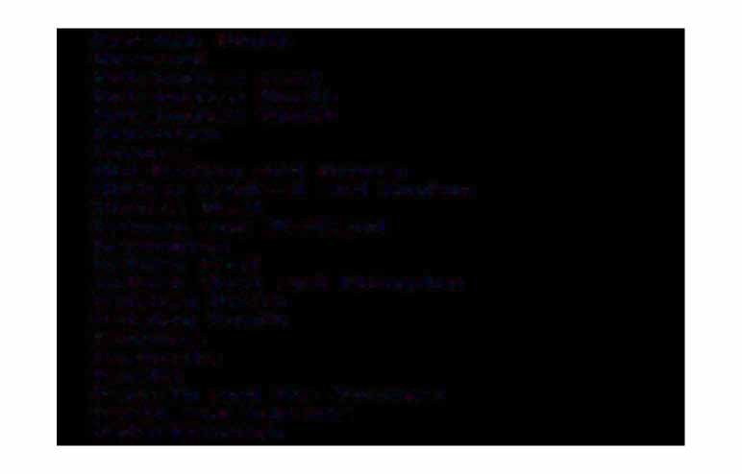Horwich South Horwood HottinghaM East HottinghaM Horth HottinghaM South Nuneaton

OgMore

Old Bexley and Sidcup OldhaM Central and Royton OldhaM West

Orkney and Shetland Orpington

Ox-ford East

Ox-ford West and Abingdon Paisley Horth

Paisley South PeckhaM PeMbroke Pendle

Penrith and the Borders Perth and Kinross Peterborough

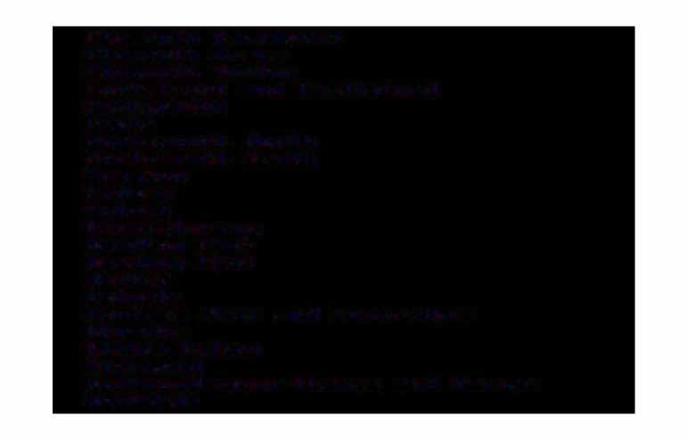PlyMouth Devonport PlyMouth Drake PlyMouth Sutton

PonteEract and CastleEord Pontypridd

Poole

PortsMouth Horth PortsMouth South Preston

Pudsey Putney Ravensbourne Reading East Reading West Redcar Reigate

RenErew West and Inverclyde Rhondda

Ribble Valley RichMond

RichMond-upon-ThaMes and Barnes Rochdale

Rocht=ord RoMf=ord

RoMsey and Waterside Ross, CroMarty and Skye Rossendale and Darwen Rother Valley

RotherhaM

Roxburgh and Berwickshire Rugby and **Kenilworth** Ruislip-Hot-thwood Rushclit=t=e

Rutland and Melton Ryedale

Sat=t=ron Walden Salt=ord East Salisbury Scarborough Sedget=ield Selby Sevenoaks

Shet=t=ield Atterclit=t=e Shet=t=ield Brightside

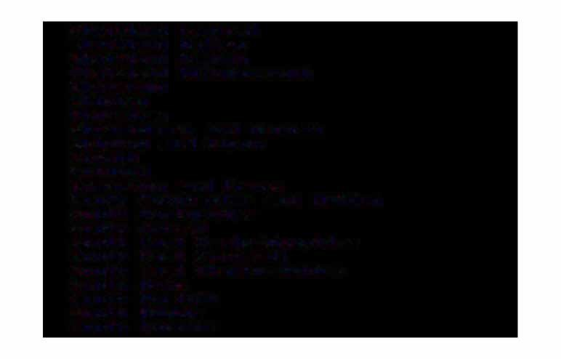Sheffield Central Sheffield HallaM Sheffield Heeley Sheffield Hillsborough Sherwood

Shipley ShorehaM

Shrewsbury and AtchaM Skipton and Ripon Slough

Solihull

SoMerton and FroMe

South Colchester and Maldon South Derbyshire

South Dorset

South East CaMbridgeshire South East Cornwall

South East Staffordshire South HaMs

South Norfolk South Ribble South Shields

South Sta��ordshire South Su��olk

South Thanet

South West Bed�ordshire South West CaMbridgeshire South West Hert�ordshire South West Hor�olk

South West Surrey South Worcestershire SouthaMpton Itchen SouthaMpton Test Southend East Southend West Southport

Southwark and BerMondsey Spelthorne

St. Albans

St. Helens Horth St. Helens South St. Ives Sta��ord

Sta��ordshire Moorlands

# Stalybridge and Hyde SSttaeMvefonragdeand Spalding SSttoirclkipnogrt

Stockton Horth

SSttookcke-toonn-SToruetnht Central Stoke-on-Trent **Horth** SSttorkatef-oornd--Torne-nAtvoSnouth Strathkelvin and Bearsden StreathaM

Stretford

SSturffoouldk Coastal

**S**Su**un**nd**d**e**er**rl**l**a**an**nd**d H**So**or**ut**t**h**h**

# SSuurttbointoannd CheaM Sutton Coldfield Swansea East

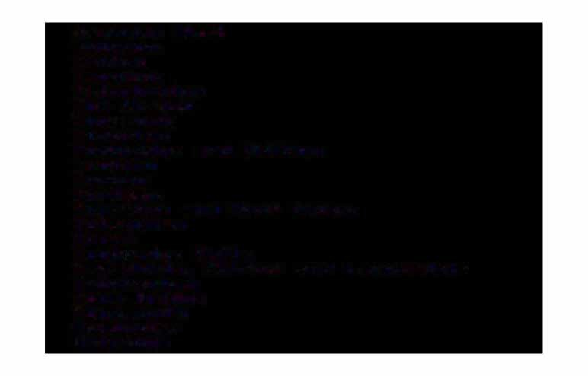Swansea West Swindon Tatton Taunton Teignbridge The Wrekin Thurrock Tiverton

Tonbridge and Malling Tooting

Torbay Tor-faen

Torridge and West Devon TottenhaM

**T**T**r**u**u**n**r**bt**o**-idge Wells

Tweeddale.,. Ettrick and Lauderdale TwickenhaM

Tyne Bridge TyneMouth UpMinster Uxbridge

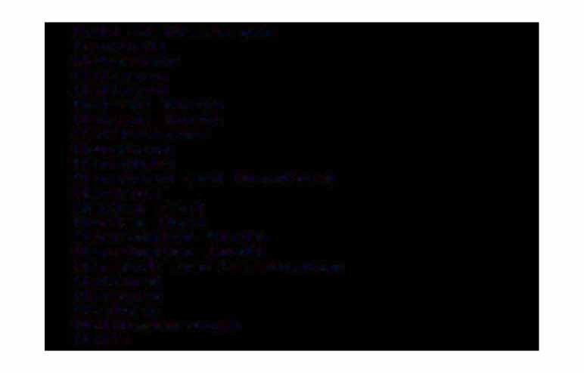Uale of GlaMorgan Uauxhall Wakefield Wallasey

Wallsend Walsall Horth Walsall South WalthaMstow Wansbeck Wansdyke

Wanstead and Woodford Wantage

Warley East Warley West Warrington Warrington South

**Horth**

Warwick and LeaMington Watford

Waveney Wealden Wellingborough Wells

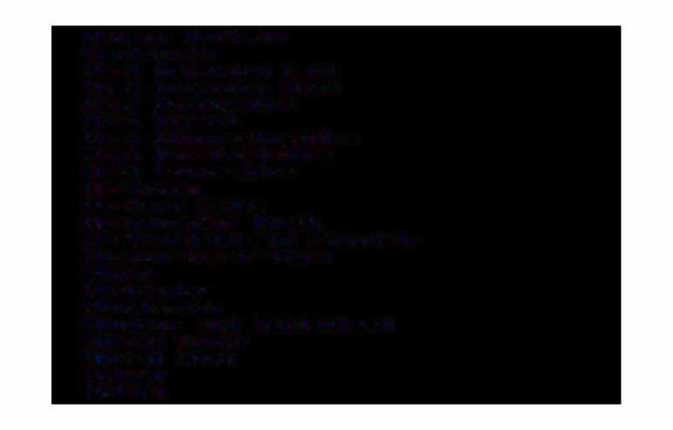Welwyn Hat�ield Wentworth

West BroMwich East West BroMwich West West Derbyshire West Dorset

West Gloucestershire West Hert�ordshire West Lancashire Westbury

Western Isles WestMinster Horth WestMorland and Lonsdale Weston-Super-Mare

Wigan **WiMbledon** Winchester

Windsor and Maidenhead Wirral South

Wirral West Witney Woking

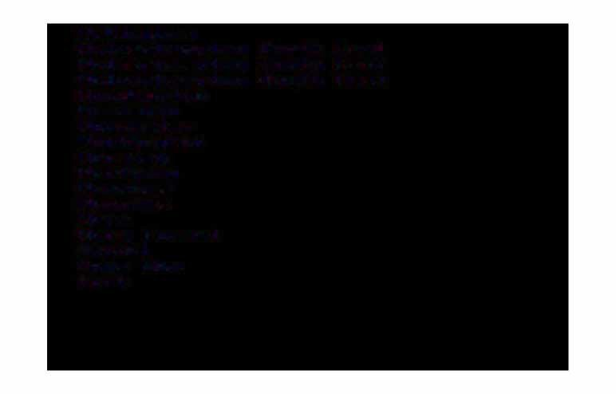Wokinghatl'II

Wolverhatl'llpton Horth East Wolverhatl'llpton South East Wolverhatl'llpton South West Woodspring

Woolwich Worcester Workington Worsley Worthing Wrexhatl'II Wycotl'llbe Wyre

Wyre Forest Yeovil

Ynys Mon York

Aberdare Aberdeen Abergavenny Abertillery Aberystwyth Abingdon Accrington Acton Airdrie Aldershot Alexandria Al-freton Alloa Alnwick Alton

AltrinchaM and Knuts-ford AMble

AMesbury AMlwch AMMan-ford Andover Annan

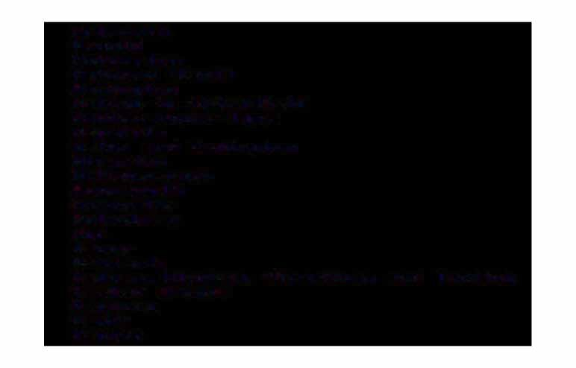Arbroath Arnold Ashburton

Ash-ford <Kent) Ashington

Ashton-in-Maker-field Ashton-under-Lyne Aspatria

Aston and Erdington Atherton Attleborough Avontr1outh

Axtr1inster Aylesbury Ayr

Bacup Bakewell

Balhatr1_. Mitchatr1_. Streathatr1 and Tooting Batr1ber Bridge

Banbury Ban-f-f Bangor

Bargoed Barking Barti11outh Barnard Castle Barnet Barnoldswick Barnsley Barnstaple Barrhead

Barrow-in-Furness Barry

Barton-on-Huti11ber Basildon Basingstoke

Bath Bathgate Batley Beauti11aris Bebington Beccles

BeckenhaM and Penge Bed-ford

Bedlington Bedworth Beeston Bellshill Belper BerMondsey

Berwick-on-Tweed Beswick and Droylsden Beverley

Bexhill Bexley Bicester Biddulph Bide-ford Biggleswade

**BillinghaM**

Bilston Birkenhead BirMinghaM Birtley

Bishop Auckland Bishops Stort-ford

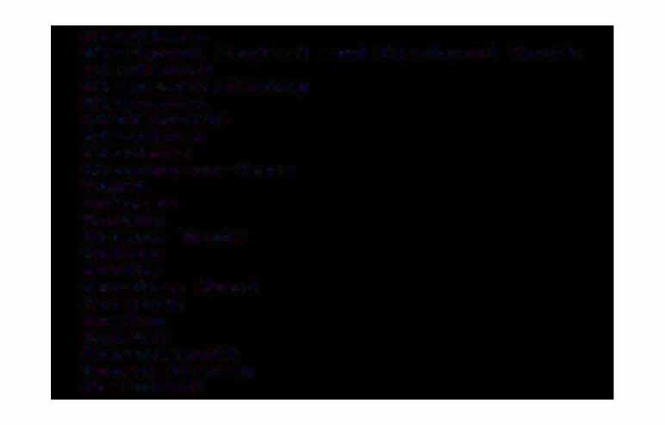Blackburn

Blackpool Central and Blackpool South Blackwood

Blaenau��estiniog Blaenavon Blairgowrie Bland�ord Blantyre

Blaydon-on-Tyne

Bly---th

Bo ness

BodMin Bognor Regis Bolton

Bootle BorehaM Wood Borough Boston Bout�ne BourneMouth Bovey Tracey Bracknell

Bradf'ord Braintree BraMley Brandon Brecon Brentwood Bridgend Bridgnorth Bridgwater Bridlington Bt�idport Brighouse

Brighton and Hove

Bristol.. BedMinster and Fishponds Brixhatl'II

Brixton.. Stockwell and West Horwood BroMley

Brotl'llsgrove and Droitwich Brownhills and Burntwood Broxburn

BrynMawr Buckie

BuckinghaM Bude Bulwell Bungay

Burgess Hill BurnhaM-on-Sea Burnley

Burnt Oak BursleM

Burton-on-Trent Bury

Bury St. Edtt1unds Buxton

Caernar-fon Caerphilly Catt1berley Catt1berwell Catt1borne and Hayle Catt1bridge Catt1buslang

Catt1den Town Catt1el-ford

CaMpbeltown Cannock Canterbury Canvey Island Cardi-f-f Cardigan Carlisle Carluke CarMarthen Castle Douglas Castle-fot�d CaterhaM

Ce-fnMawr Chapeltown Chard

ChathaM_. GillinghaM and Strood Cheadle

ChelMs-ford ChelMsley Wood CheltenhaM Chepstow CheshaM

Chester

Chester-le-Street Chesterf'ield Chichester ChippenhaM Chiswick

Chorley Christchurch Cinderf'ord Cirence:s:ter City of' London Clacton-on-Sea

ClaphaM Junction Clay Cross Cleator Moor Clevedon Clitheroe Clydebank Coalville Coatbridge CockerMouth Colchester

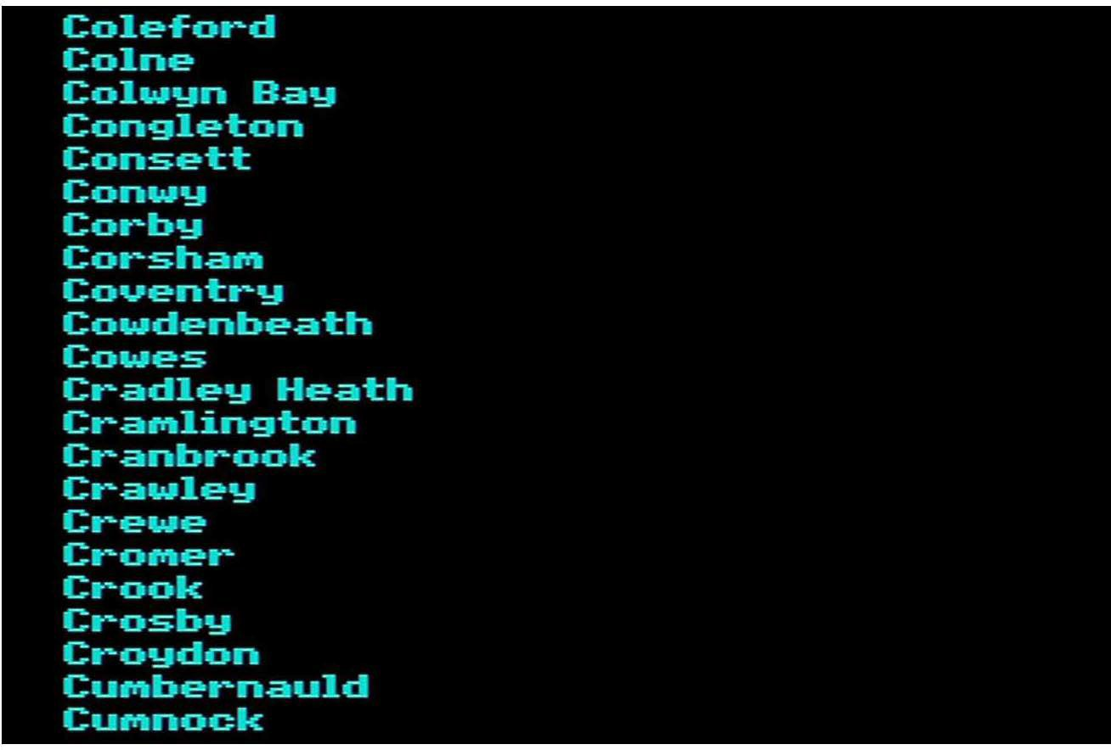

Cupar CwMbran CyMMer DagenhaM Dalkeith Darlington Dartf=ord DartMouth Darwen Daventt-y Deal Denbigh Denny Denton

Deptf=ord and Greenwich Derby

DerehaM Devizes Dewsbury Didcot Didsbut-y Dingwall

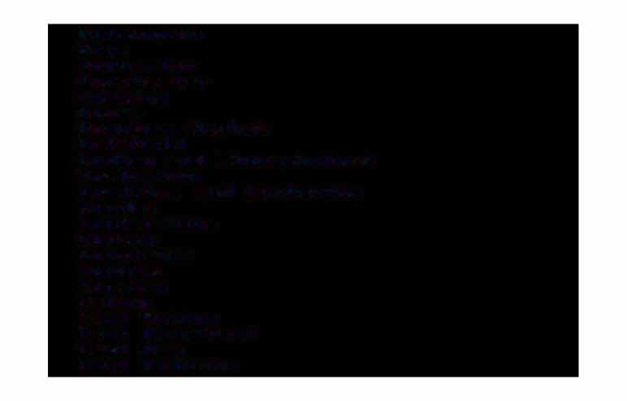Dinnington Diss Doncaster Dorchester Dorking Dover

Downhaf'l'II Market Dri-f-field

Dudley and Kingswin-ford Duf'!'llbarton

DuM-fries and Lockerbie Dundee

Dun-ferf'l'llline Dunoon Dunstable Durhaf'l'II Dursley Ealing

East Boldon East Grinstead East Haf'l'II

East Kilbride

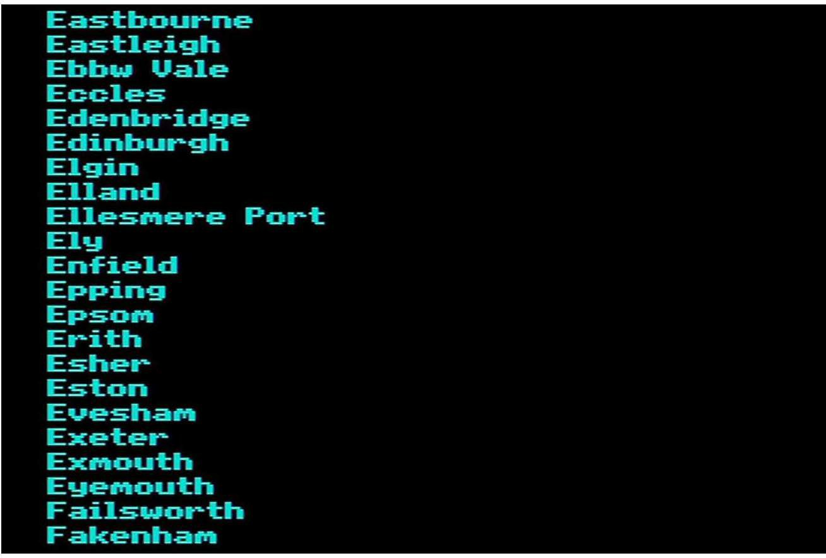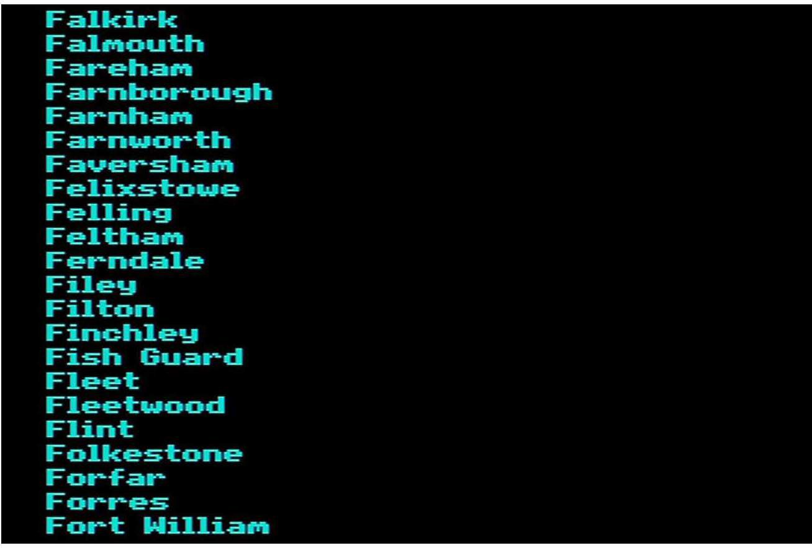

Fraserburgh Ft�otl'lle FulhaM

Gainsborough Galashiels Garnant Gateshead Girvan

Glasgow Central Glasgow West Glenrothes Glossop Gloucester Golders Green Goldthorpe Goole

Gorseinon Gosport Govan GrangeMouth Gt�anthaM Gravesend

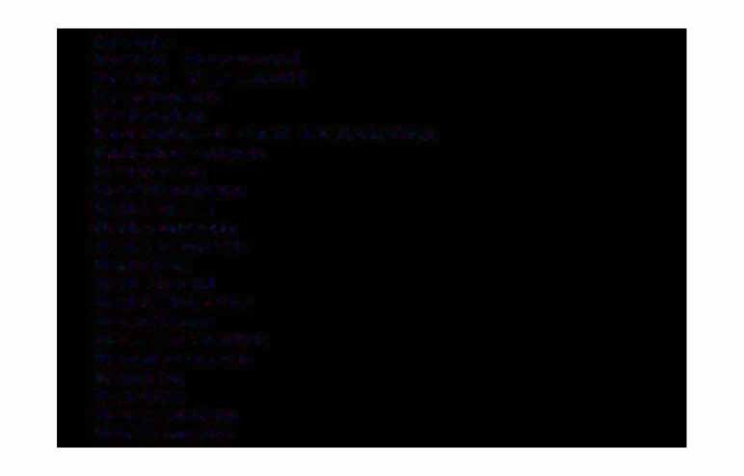Grays

Great Harwood Great YarMouth Greenock GriMsby

GuildEord and GodalMing Guisborough

Hackney Haddington HailshaM Halesowen Halesworth HaliEax Halstead Haltwhistle HaMilton HaMMersMith Handsworth Hanley Harlow Harpenden Harrogate

Harrow Hartlepool Harwich

Haslingden Hastings Hat-field Havant

Haver-fordwest Haverhill Hawick

Hayes

Haywards Heath Heanor Helensburgh Helston

Hef'!'llel Hef'!'llpstead Hef'!'llswot-th

Here-ford

Herne Bay and Whitstable Hert-ford

Hessle Hexhaf'!'II

Heywood

High WycoMbe Hillington

Hinckley and Wigston Hindley

Hitchin Hoddesdon Holbeach Holloway Holyhead Holywell Honiton Horncastle Hornchurch Hors-forth Hor:shaM Horwich

Houghton-le-Spring Hounslow

Hoylake Hoyland Hudders-field

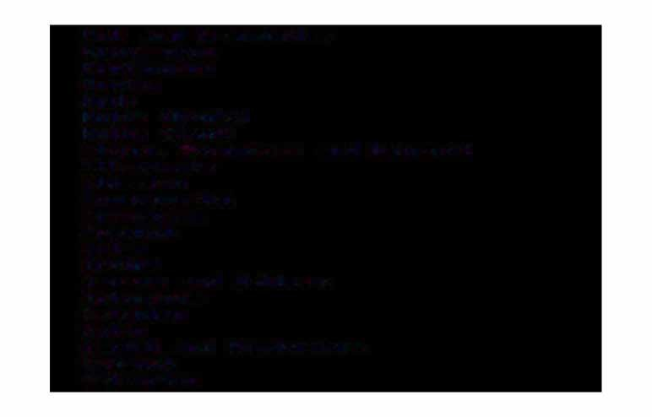Hull and BransholMe Hunstanton Huntingdon

Huntly Hyde

Hythe <Hants> Hythe <Kent)

II-ford_. Becontree and Hainault Il-fracoMbe

Ilkeston Invergordon Inverness Ipswich IrlaM

Irvine

Jarrow and Hebburn Johnstone

Keighley Kelso

Kendal and WinderMere Keswick

Kettering

KeynshaM KidderMinster Kidsgrove Kidwelly Kilbirnie KilMarnock Kilsyth Kilwinning Kings Cross Kings Lynn Kingsbridge

Kingston., RichMond and TwickenhaM Kingswood

Kirkby Kirkcaldy KirkhaM Kirkintilloch Kirkwall Knottingley LaMpeter Lanark Lancaster

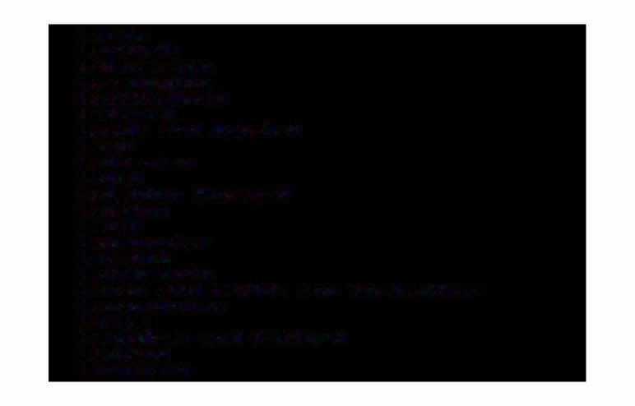Largs Larkhall Launceston LeaMington Leatherhead Ledbur,y

Leeds and Hunslet Leek

Leicester Leigh

Leighton Buzzard Leiston

Leith LeoMinster Lerwick Letchworth

Leven and Methil and Anstruther LevenshulMe

Lewes

LewishaM and Catford Leyland

Lichfield

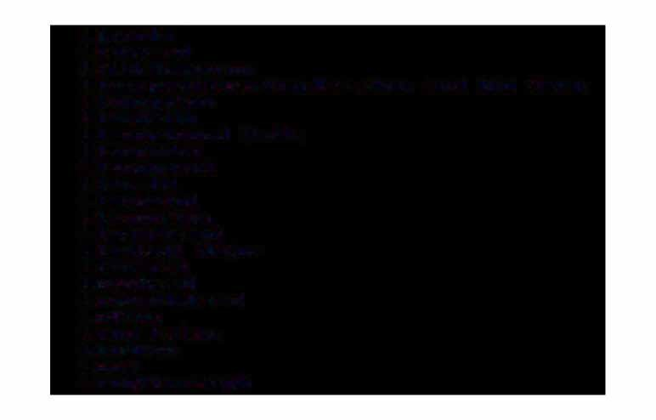Lincoln Liskeard LittlehaMpton

Liverpool_.Everton_.Garston and Old Swan Livingston

Llandeilo Llandrindod Wells Llandudno Llandyssul Llanelli

Llangef'ni Llangollen Llantrisant Llantwit Major Llanwrst Loanhead Lochgilphead Lof'tus

Long Eaton Longton Looe

Loughborough

Loughton Louth Lowesto-ft Ludlow Luton Lydney Lyf'l'llington Mablethorpe

Maccles-field Machynlleth and Tywyn Madeley

Maesteg Maidenhead Maidstone

Maldon and Burnhaf'l'll-on-Crouch Maltby

Malton Malvet�n

Manchester and Moss Side Mans-field

March Margate

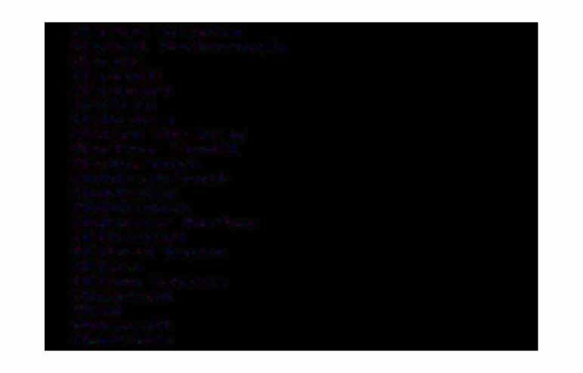Market Drayton Market Harborough Marple

Maryhill Maryport Matlock Melkshan Melton Mowbray Merthyr Tyd-fil Mexborough Middlesbrough Middleton Middlewich

Midsoner Horton Mildenhall

Mil-ford Haven Millon

Milton Keynes Minehead

Mold Monnouth Montrose

Mot�ecaMbe Morley Morpeth Morriston Mossley Motherwell Musselburgh Nairn Nantwich Heath

Helson Heston Hetherf=ield Hew Mills Hew RoMney Newark Hewbridge Newburn Newbury

Hewcastle-under-LyMe

Newcastle-upon-Tyne and Shields Road Hewhaven

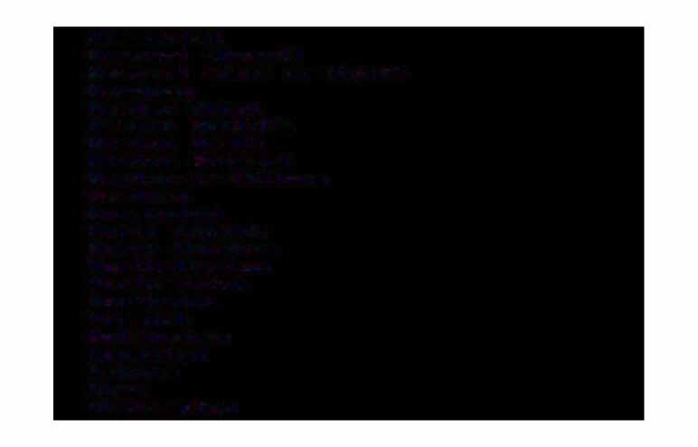HewMarket Newport <Gwent)

Newport <Isle o-f Wight) Hewquay

Newton Abbot Newton Aycli-f-fe Newton Heath Newton Stewart Newton-le-Willows Newtown HorManton

Horth Shields Horth WalshaM Horthallerton HorthaMpton Horthwich Horwich HottinghaM Nuneaton OakhaM

Ohan OkehaMpton

Oldbury

OldhaM and Chadderton OrMskirk

Orpington Oswestry Otley OxEord PadihaM Paignton Paisley

Parkhead and Easterhouse Peebles

PeMbroke Dock Penarth Penicuik Penrith Penygroes Penzance Pershore Perth Peterborough Peterhead

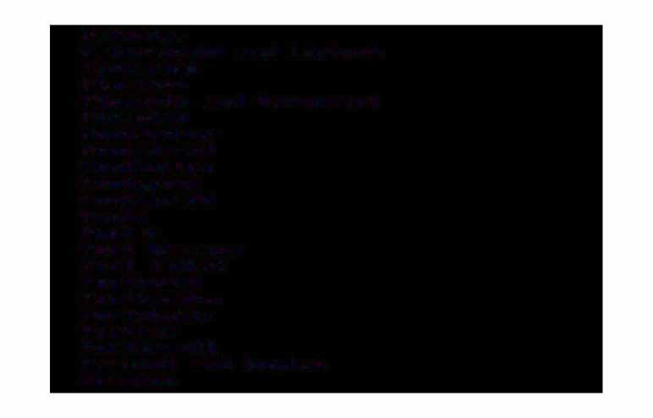Peterlee

Petersfield and Liphook Pickering

Plaistow

PlyMouth and Devonport PlyMpton

Pontardawe Pontefract Pontlottyn Pontypool Pontypridd Poole Poplar

Port Glasgow Port Talbot Porthcawl PorthMadog Portobello Portree PortsMouth

Prescot and Huyton Preston

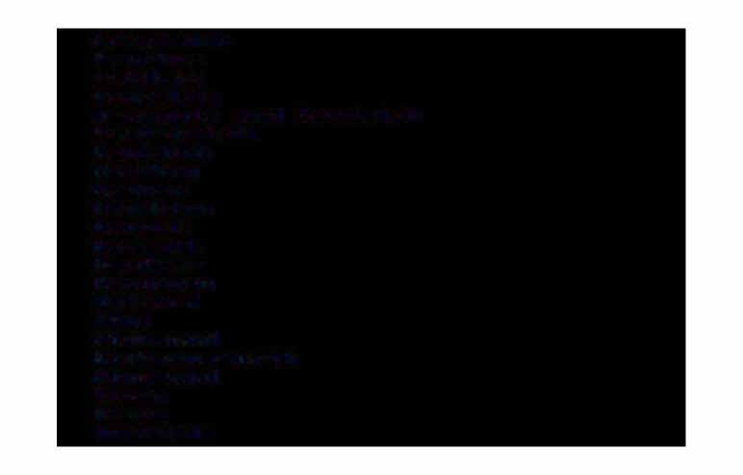Prestwich Prudhoe Pwllheli Radeli-f-fe

R.aMsg.ate and Sandwich R.awtenst.all

Rayleigh Reading Redcar Redditch Redhill Redruth Ren-frew Resolven Ret-ford Rhyl RichMond

RickM.answorth Ringwood

Ripon Rise.a Rochdale

RoMi-ford Roti'llsey

Ross-on-Wye Rotherh.ati'II Rothes.ay Rothwell Royston Royton Rugby Rugeley Ruislip Runcorn Rushden Rutherglen Ryde

S.a-f-fron Walden Sal-ford Salisbury Salt.ash S.altburn Saltco.ats S.andb.ach

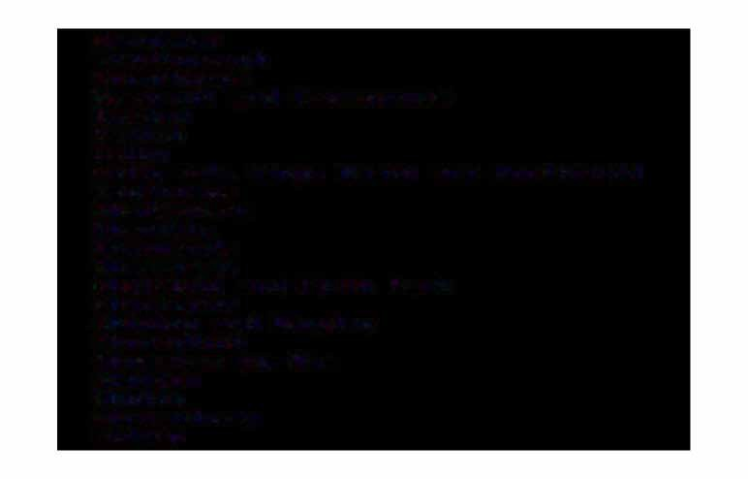Sanquhar Scarborough Scunthorpe

SeacroEt and Crossgates SeahaM

Seaton

Selby Oak_. Kings Heath and HorthEield Sevenoaks

Selly

ShaEtsbury Shanklin Shawlands Sheerness

SheE�ield and Firth Park Sherborne

Shipley and Bingley Shoreditch ShorehaM-by-Sea Shotton

Shotts Shrewsbury Sidcup

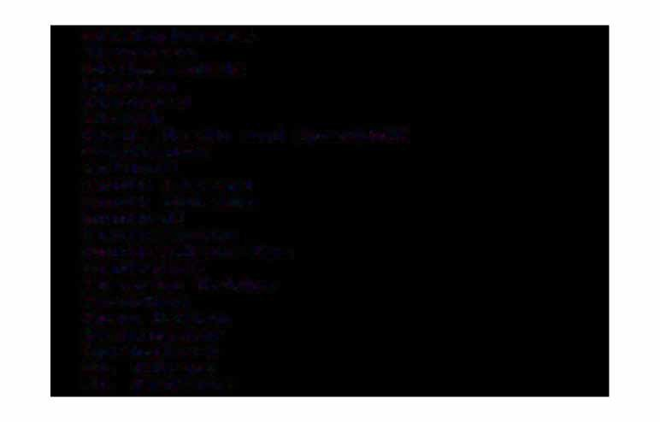Sittingbourne Skegness SkelMersdale Skipton

Slea-ford Slough

SMall Heath and Sparkhill SMethwick

**Solihull**

South ElMsall South Shields Southall SouthaMpton Southend-on-Sea Southport Sowerby Bridge Spalding

Spen Ualle,y Spenn,yMoor Springburn St. Albans St. Andrews

St. Annes St. Austell St. Helens St. Ives

St. Marylebone St. Heots Stat=t=ord Staines Stalybridge StaMf=ot�d

Stant=ord-le-Hope Stanley

Staveley and Dront=ield Stepney

Stevenage Stirling Stockport

Stockton and Thornaby and YarM Stoke-on-Trent

Stone Stornoway Stourbridge

Stourport StowMarket Stranraer Strat-ford

Strat-ford-on-Avon Street and Wells Stret-ford

Stroud and Hailsworth Sudbury

Sunderland Sutton

Sutton Cold-field Sutton-in-Ash-field Swadlincote

Swa-f-fhaM Swanage Swansea Swindon Swinton TaMworth Taunton Tavistock

TeignMouth Telf'ord Tenby Tewkesbury Thetf'ord Thirsk Thorne

Thornton Clevelys Thurso

Tilbury Tipton Tiverton TodMorden Tonbridge Tonypandy Tonyref'ail Torquay Totnes TottenhaM Towcester Tredegar Treharris

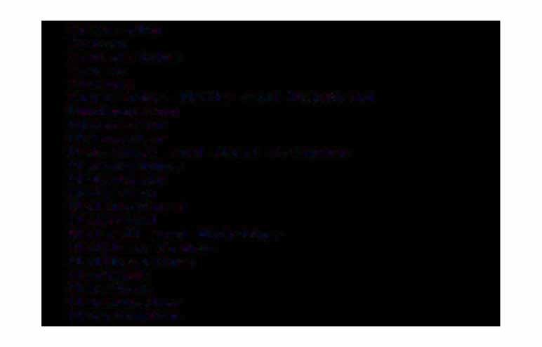Treorchy Troon Trowbridge Truro Tuf'!'lble

Tunbridge Wells and Uckfield Uddingston

Ulverston Uttoxeter

Uxbridge and West Drayton Wadebridge

Wake-field Wallasey Walling-ford Wallsend

Walsall and Aldridge Walthaf'!'I Cross Walthaf'!'lstow

Wantage Warehaf'!'I Warf'!'linster Warrington

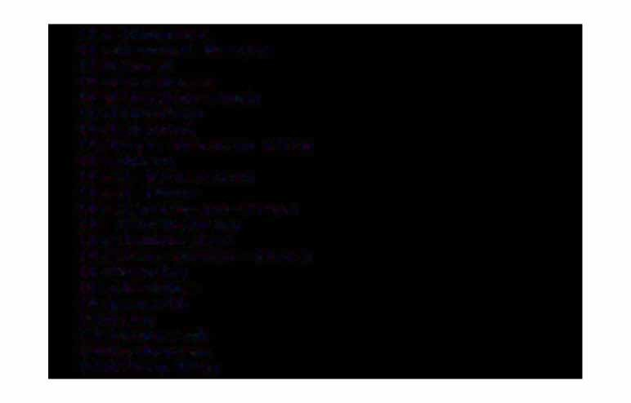Washington Washwood Heath Wat-ford Wednesbury Wellingborough Wellington Welshpool

Welwyn Garden City WeMbley

West Bt�oMwich West Moor Westbury-on-Try"' Westhoughton WestMinister

Weston-super-Mare Wetherby

Weybridge WeyMouth Whitby Whitchurch Whitehaven Whitley Bay

Wick Widnes Wigan

Willenhall and Wednes-field Willesden and Kilburn Wiltl'lslow

Witl'lbledon Witl'lborne Winchester Windsot- Wingate Wins-ford Wisbech Wishaw Withatl'I Witney Woking Wokinghatl'I

Wolverhatl'lpton Wotl'lbwell Woodbt-idge Woodgreen

